# A Software Project On

**“PropKart”**

**In the Partial fulfillment of**

**Master of Science –In Information Technology- Integrated**

### (IMSc(IT))- Semester-5

#### Developed By:

|  |  |  |
| --- | --- | --- |
| **Sr No** | **Enrollment No** | **Name of the Students** |
| **1.** | **23004500210215** | **Vivek Prajapati** |
| **2.** | **23004500210216** | **Krisha Purohit** |

**Group No: IMSc(IT)_6 Under the Guidance of** **Dr./Prof. Urvika Mam**

### Submitted To

**L.J. School of Computer Applications**

L.J.Campus, Near Sanand Cross Roads, S.G.Road, Ahmedabad - 382210 Ph. No.: 9099063417

#### CERTIFICATE

**Enrollment No**:23004500210215 **Seat No:**

This is to certify that Mr.Ms. **Vivek Prajapati** of Master of Science (Information Technology) Integrated,Semester 5, Div C, Roll No 34 has satisfactorily completed her project title **PropKart** in **S/W Project**

**(050021001)** under the supervision of

**Internal Guide Head of the Department Name of the Guide Dr. Jignesh Doshi**

**Dr/Prof. Urvika Soni**

**Date of Submission:**

#### CERTIFICATE

**Enrollment No**:23004500210216 **Seat No:**

This is to certify that Mr.Ms. **Krisha Purohit** of Master of Science (Information Technology) Integrated,Semester 5, Div C, Roll No 55 has satisfactorily completed her project title **PropKart** in **S/W Project**

**(050021001)** under the supervision of

**Internal Guide Head of the Department Name of the Guide Dr. Jignesh Doshi**

**Dr/Prof. Urvika Soni**

**Date of Submission:**

## Plagiarism Declaration

To whom so ever it may concern

I/we confirm that **PropKart** Project (document/PPT or Code) is our own work, is not copied

from any other person's work (published or unpublished or generated using CHATGPT/AI),

and has not previously submitted for assessment either at University or elsewhere. We

confirm that we have read and understood the rules regulations on plagiarism in LJ University.

|  |  |  |  |
| --- | --- | --- | --- |
| **Sr. No.** | **Enrollment No.** | **Name of the student** | **Signature** |
| 1 | 23004500210215 | Vivek Prajapati |  |
| 2 | 23004500210216 | Krisha Purohit |  |

pg. 1

**Components worked on**

|  |  |  |  |
| --- | --- | --- | --- |
| **Se No.** | **Name of the Components** | **Sr. No** | **Name of the Components** |
| **1.** | Login/ Logout | **16.** | Property Visit Schedule(Buyer/Seller) |
| **2.** | User Registration (Email OTP) | **17.** | Messaging System (Buyer/Seller) |
| **3.** | Password reset (OTP) | **18.** | AI Chatbot Assistant |
| **4.** | Role Model (Buyer/Seller) | **19.** | Notification |
| **5.** | Static Pages (About/Contact) | **20.** | Property Search |
| **6.** | Profile (View/Edit) | **21.** | Sorting & Filtering (Buyer) |
| **7.** | Property Catalog (Buyer) | **22.** | Django Admin Panel |
| **8.** | Property Details & Gallery (Buyer) | **23.** |  |
| **9.** | Property View Tracking | **24.** |  |
| **10.** | Seller Dashboard (Seller) | **25.** |  |
| **11** | My Properties (Seller) | **26.** |  |
| **12** | Property CRUD (Seller) | **27.** |  |
| **13** | Property Bulk Action (Delete/Import) | **28.** |  |
| **14** | Wishlist List (Buyer) | **29.** |  |
| **15** | Property Enquiries (Buyer/Seller) | **30.** |  |

Date: Signature:

pg. 2

|  |  |  |  |
| --- | --- | --- | --- |
| **Se No.** | **Name of the Components** | **Sr. No** | **Name of the Components** |
| **1.** |  | **16.** |  |
| **2.** |  | **17.** |  |
| **3.** |  | **18.** |  |
| **4.** |  | **19.** |  |
| **5.** |  | **20.** |  |
| **6.** |  | **21.** |  |
| **7.** |  | **22.** |  |
| **8.** |  | **23.** |  |
| **9.** |  | **24.** |  |
| **10.** |  | **25.** |  |
| **11** |  | **26.** |  |
| **12** |  | **27.** |  |
| **13** |  | **28.** |  |
| **14** |  | **29.** |  |
| **15** |  | **30.** |  |

Date: Signature:

pg. 3

I would like to take this opportunity to express my sincere gratitude and appreciation to all those who have

supported me in the successful completion of my Semester 5 project.

First and foremost, I would like to extend my heartfelt thanks to **Dr. Jignesh Doshi**, Head of the Department,

**M.Sc. (Information Technology), LJ School of Computer Applications, LJ University**, for his

continuous encouragement, expert guidance, and invaluable support throughout the duration of this project.

I am extremely thankful to my **internal guide, Ms. Urvika Soni**, for providing insightful feedback, motivation,

and guidance at every stage of the project.

I would also like to acknowledge the contribution of my **external guide, Mr./Ms. Jignesh Doshi**, whose

expertise and suggestions greatly enhanced the quality of my work.

I sincerely appreciate the efforts of all faculty members and lab instructors who provided assistance and support whenever needed.

Lastly, I am grateful to my **family and friends** for their constant support, motivation, and encouragement

throughout the project journey.

**Enrolment No(s):** 23004500210215

**Name(s): & Signature(s):** Vivek Prajapati

**Semester:** 5

**Project Title:** PropKart

pg. 4

I would like to take this opportunity to express my sincere gratitude and appreciation to all those who have

supported me in the successful completion of my Semester 5 project.

First and foremost, I would like to extend my heartfelt thanks to **Dr. Jignesh Doshi**, Head of the Department,

**M.Sc. (Information Technology), LJ School of Computer Applications, LJ University**, for his

continuous encouragement, expert guidance, and invaluable support throughout the duration of this project.

I am extremely thankful to my **internal guide, Ms. Urvika Soni**, for providing insightful feedback, motivation,

and guidance at every stage of the project.

I would also like to acknowledge the contribution of my **external guide, Mr./Ms. Jignesh Doshi**, whose

expertise and suggestions greatly enhanced the quality of my work.

I sincerely appreciate the efforts of all faculty members and lab instructors who provided assistance and

support whenever needed.

Lastly, I am grateful to my **family and friends** for their constant support, motivation, and encouragement

throughout the project journey.

**Enrolment No(s)** 23004500210216

**Name(s): & Signature(s)** Krisha Purohit

**Semester:** 5

**Project Title:** PropKart

pg. 5

# INDEX

|  |  |  |
| --- | --- | --- |
| **Sr. No.** | **TABLE OF CONTENTS** | **Page No.** |
| **1. 9.** | **INTROODUCTION** |  |
|  | 1.1 Existing System |  |
|  | 1.2 Need for the New System |  |
|  | 1.3 Objective of the New System |  |
|  | 1.4 Problem Definition |  |
|  | 1.5 Scope of the project and Core Components |  |
|  | 1.6 Project Profile |  |
|  | 1.7 Assumptions and Constraints |  |
|  | 1.8 Advantages and Limitations of the Proposed System |  |
|  | 1.9 Proposed Time Line Chart |  |
| **2.** | **REQUIREMENT DETERMINATION & ANALYSIS** |  |
|  | 2.1 Requirement Determination |  |
|  | 2.2 Targeted Users |  |
|  | **2.3 Requirement Specification** |  |
| **3.** | **SYSTEM DESIGN** |  |
|  | 3.1 Use Case Diagram |  |
|  | 3.2 Class Diagram |  |
|  | 3.3 Interaction Diagram |  |
|  | 3.4 Activity Diagram |  |
|  | 3.5 Data Dictionary |  |
|  | **3.6 User Interface Design (Using Expanded Use case)** |  |
|  | **3.7 Test Cases** |  |
|  | **3.8 Report Design** |  |
| **4.** | **DEVELOPMENT** |  |
|  | 4.1 **Coding Standards** |  |
|  | 4.2 Screenshots |  |
| **5.** | **AGILE DOCUMENTATION** |  |
|  | 5.1 Agile Project Charter |  |
|  | 5.2 Agile Road map/Schedule |  |
|  | 5.3 Agile Project Plan |  |
|  | 5.4 Agile User Story |  |
|  | 5.5 Agile Release Plan |  |

pg. 6

|  |  |  |
| --- | --- | --- |
|  | 5.6 Agile Sprint Backlog |  |
|  | 5.7 Agile Test Plan |  |
|  | 5.8 Earned-value and burn charts |  |
| **6.** | **Testing** |  |
|  | 6.1 Testing Method |  |
|  | 6.2 Test Cases |  |
| **7.** | **PROPOSED ENHANCEMENT** |  |
| **8.** | **Conclusion** |  |
| **9.** | **Project Learnings** |  |
| **10.** | **BIBLIOGRAPHY** |  |

pg. 7

**1.INTRODUCTION:**

PropKart is a modern, Django-based real estate platform that streamlines property discovery and transactions for buyers and sellers through a secure, intuitive, and scalable web application. The system centralizes core marketplace workflows—listing management, buyer discovery, enquiries, visit scheduling, messaging, and notifications—while enforcing role-based access and OTP-backed account security.

* 1. **Existing System:**

**The current landscape for property discovery and transactions is fragmented, manual, and error‑prone, resulting in poor user experience and operational inefficiencies.**

* **Scattered Listings:** Properties are dispersed across multiple channels (portals, social media, brokers), with no unified source of truth**.**
* **Manual, Slow Processes:** Core workflows (viewing schedules, offer submission, follow-ups) rely on calls and emails, creating delays and missed opportunities.
* **Limited Discovery:** Basic or inconsistent filtering/sorting hampers targeted searches (price range, area, amenities, property type).
* **Stale or Inaccurate Data:** Listings are not consistently maintained; availability, pricing, and details become outdated quickly.
* **Low Transparency and Trust:** Unverified profiles and ad-hoc communication lead to ambiguity, misaligned expectations, and reduced confidence.
* **Fragmented Communication:** Buyer–seller exchanges happen across disparate apps, making context tracking and follow-ups difficult.
* **Minimal Analytics/Insights:** Stakeholders lack visibility into engagement (views, enquiries, visits), hindering data-driven decisions.

* 1. **Need for New System:**
* **Business**
* Centralize listings to improve discovery and lead conversion.
* Give sellers KPIs and bulk tools to manage inventory efficiently.
* **Users**
* Up-to-date, verified property info with clear details and media.
* Fast workflows: enquire, wishlist, schedule visits, and message sellers.
* **Operations**
* Replace manual steps with structured enquiries/visits and unified notifications.
* Role-aware UIs separating buyer and seller tasks.
* **Security & Trust**
* OTP-backed signup/reset and strict authorization on seller actions.
* Reduce spam and spoofing; ensure data accuracy.
* **Technical**
* Maintainable Django stack with optimized queries and scalable media handling.
* Extensible APIs for messaging, notifications, and AI assistance.

**1.3 Objective Of New System:**

# Deliver a centralized, trustworthy marketplace for discovering and managing property listings.

# Streamline core workflows (enquiries, visits, messaging) to reduce manual effort and time-to-response.

# Empower sellers with efficient listing tools (CRUD, bulk import, visibility control) and feedback on how well their products are doing.

# Enhance trust and security via OTP-backed registration/reset and role-based authorization.

# Improve user experience with clear property details, media galleries, wishlists, and guided actions.

# Provide reliable notifications and status tracking for messages, enquiries, and visit updates.

# Ensure maintainable, scalable architecture (optimized queries, robust media handling, extensible APIs).

# 1.4 Problem Definition:

# PropKart addresses the fragmented, manual, and untrusted nature of current property discovery and transactions:

# Core Problem: Listings are scattered, often outdated, and lack reliable verification; buyer–seller interactions are manual and inconsistent.

# Impact: Low discovery quality, slow response cycles, missed leads, and reduced confidence among users.

# Requirements:

# Unify listings into a single, accurate source with verified seller identities.

# Provide structured workflows for enquiries, messaging, and visit scheduling.

# Surface operational visibility (KPIs) for sellers and timely notifications for all users.

# Enforce secure access and OTP-backed flows to protect accounts and data.

# Success Criteria: Faster time-to-response, higher lead conversion, improved data freshness, reduced manual overhead, and measurable user trust.

# 1.5 Key Modules:

* **Authentication & Accounts**
* Responsibilities: Login, logout, registration with email OTP, password reset OTP.
* Interfaces: login, logout, register, verify_otp, forget_password, verify_password_reset_otp, reset_password
* Models: User, PasswordResetToken
* **Role & Seller Onboarding**
* Responsibilities: Buyer-by-default, seller verification via token link.
* Interfaces: become_seller_request, verify_seller
* Models: User, SellerRequest
* **Property Catalog**
* Responsibilities: Home feed, buyer listing view (verified, visible), detail pages.
* Interfaces: index, property_list, property_detail, increment_property_view
* Models: Property, PropertyImage
* **Seller Property Management**
* Responsibilities: Create, update, delete, bulk delete properties; toggle visibility.
* Interfaces: property_create, property_update, property_delete, properties_bulk_delete, toggle_property_visibility
* Models: Property, PropertyImage
* **Property Import**
* Responsibilities: CSV + ZIP bulk import, validation, deduplication.
* Interfaces: seller_import_properties
* Models: Property, PropertyImportKey, PropertyImage
* **Wishlist**
* Responsibilities: Save/unsave properties, list saved items.
* Interfaces: wishlist_toggle, wishlist_list
* Models: Wishlist
* **Enquiries**
* Responsibilities: Submit property enquiries; seller inbox and actions.
* Interfaces: submit_enquiry, seller_enquiries, delete_enquiry, mark_enquiry_replied
* Models: Enquiry, Notification
* **Visit Scheduling**
* Responsibilities: Request visits (buyer); manage status (seller); buyer list/cancel.
* Interfaces: request_visit, seller_visit_requests, update_visit_request, buyer_visit_requests, cancel_visit_request
* Models: VisitRequest, Notification
* **Messaging**
* Responsibilities: Buyer–seller threaded conversations per property; reply API.
* Interfaces: buyer_messages, seller_messages, message_reply
* Models: Message, Notification
* **Notifications**
* Responsibilities: Fetch unread/all; mark read/all.
* Interfaces: notifications_list, notifications_mark_read, notifications_mark_all_read
* Models: Notification
* **Seller Dashboard & Analytics**
* Responsibilities: KPIs (properties, enquiries, visits, views); analytics stub.
* Interfaces: seller_dashboard, seller_analytics
* **AI Chat Assistant APIs**
* Responsibilities: Ask, history, new session, clear, conversation, delete/clear conversation.
* Interfaces: chat_ask, chat_history, chat_new_session, chat_clear, chat_conversation, chat_delete_messages, chat_clear_conversation
* Models: ChatSession, ChatMessage
* **Administration**
* Responsibilities: Platform administration via Django Admin; custom index template.
* Interfaces: Django Admin, templates/admin/index.html

# 1.6 Core Components:

# Authentication and Account

# Login, logout, registration with email OTP, password reset OTP.

# Models: User, PasswordResetToken.

# Roles and Seller Verification

# Buyer-by-default; seller onboarding via tokenized verification.

# Models: User, SellerRequest.

# Property Management

# Core listing domain: create, update, delete, bulk delete, visibility toggle.

# Models: Property, PropertyImage, PropertyImportKey.

# Property Discovery

# Home feed, buyer catalog (verified, visible), property detail with gallery.

# Views: index, property_list, property_detail.

# Engagement Tracking

# Unique viewer tracking and view counter per property.

# View: increment_property_view; fields: views, viewers.

# Wishlist

# Save/unsave and list saved properties.

# Model: Wishlist.

# Enquiries

# Submit enquiry; seller inbox and actions (delete/mark replied).

# Models: Enquiry, Notification.

# Visit Scheduling

# Buyer requests; seller management (approve/reject/confirm); buyer list/cancel.

# Model: VisitRequest.

# Messaging

# Buyer–seller threaded conversations per property; reply API.

# Model: Message.

# Notifications

# List unread/all; mark read/all; event-driven creation.

# Model: Notification.

# Seller Workspace

# Seller dashboard KPIs; analytics stub; support page.

# Views: seller_dashboard, seller_analytics, seller_support.

# Chat Assistant APIs

# Ask/history/new/clear/conversation; delete/clear conversation.

# Models: ChatSession, ChatMessage.

# Administration

# Django Admin with custom index template for ops oversight.

# Presentation Layer

# Server-rendered templates and static assets (Bootstrap,sliders, custom JS/CSS).

# 1.7 Project Profile:

|  |  |
| --- | --- |
| Project Name | PropKart |
| Developed by | Krisha PurohitVivek Prajapati |
| Front-End | Html, CSS, JavaScript |
| Back-End | Python |
| Server | SQLite |
| Framework/Tools | Django, Bootstrap, Tiny Slider |
| Diagram Builder | Draw.io |

# Assumptions and Constraints:

* **Assumptions**
* Users have modern devices and stable internet (recent mobile/desktop, current browsers).
* Listing data (details, photos, pricing, availability) provided by sellers/agents is accurate and lawful.
* Email (SMTP) for OTP delivery is available and reliable during critical flows.
* Media storage for images is provisioned and accessible per environment.
* Stakeholders (product/ops) are available for timely feedback, approvals, and content reviews.
* Environment secrets (email creds, API keys) are securely managed and rotated when needed.
* Deployment targets provide persistent storage for the database and media.
* Time zone and locale defaults (Asia/Kolkata, en-US) are acceptable for primary users.
* **Constraints:**
* **Timeline:** The project must be completed within a specific timeframe, with a firm launch date.
* **Budget:** We cannot spend more than the allocated budget for development and hosting.
* **Legal Compliance:** The website must follow all laws regarding data privacy and fair housing.
* **Technology:** We must build the website using the specific technology stack that was chosen to ensure it's easy to maintain and scale.

**1.9Advantages and Limitations of the System:**

* **Advantages:**
* **Increased Reach and Visibility:** The website allows properties to be seen by a vast, global audience 24/7, greatly expanding the pool of potential buyers or renters beyond a local area.
* **Enhanced Convenience:** Users can browse listings, view virtual tours, and compare properties from anywhere at any time, which saves time and effort compared to traditional methods.
* **Cost-Effectiveness:** For sellers, online platforms can be a more affordable way to list and market a property, as they may reduce or eliminate the need for expensive real estate agent commissions.
* **Limitations:**
* **Timeline:** Delivery must meet the agreed milestones and firm launch date**.**
* **Budget:** Development, testing, hosting, and support must stay within allocation**.**
* **Legal/Compliance:** Adhere to data privacy (e.g., GDPR-equivalent where applicable), fair housing/real estate advertising rules, and email/anti-spam policies.
* **Technology Stack:** Implement with Django (Python), Django Templates (HTML/CSS/JS), and configured RDBMS (SQLite for dev; MySQL/PostgreSQL for prod) to ensure maintainability and scalability.
* **Security:** Enforce OTP for sensitive flows, role-based access, secure credential management, and input/file validation.
* **Performance:** Optimize list/detail queries and media handling; respect file size/type limits for imports.
* **Availability:** SMTP must be reachable for OTP; outages may delay registration/reset.
* **Data Quality:** Platform depends on timely, accurate listing data from sellers/agents.
* **Operations:** Static/media storage and backups must be provisioned per environment.

2. **REQUIREMENT DETERMINATION & ANALYSIS**

**2.1 Requirement Determination**

* **Stakeholders**: Product owner/admin, buyers (visitor/authenticated), verified sellers, engineering/QA.
* **Methods**: Brief stakeholder interviews, pain-point analysis, codebase review, and competitive scan.
* **Baseline Requirements**:
  + Functional (MVP): OTP auth, roles (buyer/seller), property CRUD, catalog/detail, enquiries, visits, messaging, notifications, admin.
  + Non-Functional: Security (OTP, RBAC), performance (optimized queries), reliability (validation/error handling), compliance (PII).
* **Priorities**: Must-have (above MVP), Should-have (wishlist, import, seller), Could-have (advanced search/sorting, analytics expansion).
* **Validation**: Map each requirement to routes/models; define acceptance criteria per user flow; milestone reviews for sign-off.

**2.2 Targeted Users**

* **Buyers (Authenticated)**
  + **Browse listings, view details, enquire, message sellers, wishlist, request/cancel visits.**
* **Visitors (Unauthenticated)**
  + **Discover properties, view details, submit basic enquiries/visit requests (limited).**
* **Sellers (Verified)**
  + **Manage listings (CRUD, bulk import, visibility), handle enquiries and visits, view KPIs, message buyers.**
* **Administrators**
  + **Oversee platform via Django Admin: users, listings, content, and operational governance.**

**2.3 Requirement Specification**

**Functional Requirements (FR)**

* **FR-01 Authentication:** Login, Logout (sessions).
* **FR-02 Registration (OTP):** Email OTP verification before account activation.
* **FR-03 Password Reset (OTP):** Request, verify, set new password.
* **FR-04 Roles:** Buyer (default), Seller (after verification).
* **FR-05 Seller Onboarding:** Request seller access; email token verification**.**
* **FR-06 Home Feed:** Show latest verified, visible properties.
* **FR-07 Catalog:** List properties (exclude own); basic ordering**.**
* **FR-08 Property Detail:** Show details and image gallery.
* **FR-09 View Tracking:** Increment unique views per property**.**
* **FR-10 Property Management (Seller):** Create, Update, Delete**.**
* **FR-11 Property Bulk Delete (Seller).**
* **FR-12 Visibility Toggle (Seller):** Hide/Show listing to buyers**.**
* **FR-13 Property Import:** CSV + ZIP images with validation/dedupe**.**
* **FR-14 Wishlist:** Toggle and list saved properties (buyer).
* **FR-15 Enquiry: Submit enquiry;** notify seller.
* **FR-16 Enquiry Management (Seller):** List, delete, mark replied.
* **FR-17 Visit Requests (Buyer):** Create, list, cancel pending.
* **FR-18 Visit Management (Seller):** List, approve/reject/confirm**.**
* **FR-19 Messaging:** Buyer↔Seller threads per property; reply API.
* **FR-20 Notifications:** List unread/all; mark read/all.
* **FR-21 Seller Dashboard:** KPIs (properties, enquiries, visits, views).
* **FR-22 Static Pages:** About, Contact.
* **FR-23 Admin:** Django Admin access for platform management.
* **FR-24 Chat Assistant APIs:** Ask, history, new, clear, conversation, delete/clear-conversation.

**Non-Functional Requirements (NFR)**

* **NFR-01 Security**: OTP for signup/reset; role-based authorization; input/file validation.
* **NFR-02 Performance:** Optimized queries (select_related/prefetch_related); responsive pages.
* **NFR-03 Reliability:** Graceful error handling; validation for imports/uploads.
* **NFR-04 Usability:** Clear flows for enquiry, visits, messaging; consistent UI**.**
* **NFR-05 Maintainability:** Modular Django structure; clear models/views/routes.
* **NFR-06 Compliance:** Responsible handling of PII; email/anti-spam adherence.
* **NFR-07 Scalability:** Dev DB SQLite; media storage ready.
* **NFR-08 Availability:** SMTP dependency for OTP; fallback messaging for failures.
* **NFR-09 Observability:** Basic KPIs available to sellers; auditability via persisted records.

**3. SYSTEM DESIGN**

3.1 Use Case Diagram

* Guest

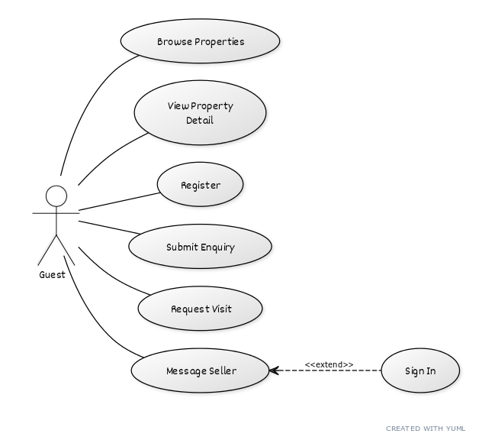

* Buyer

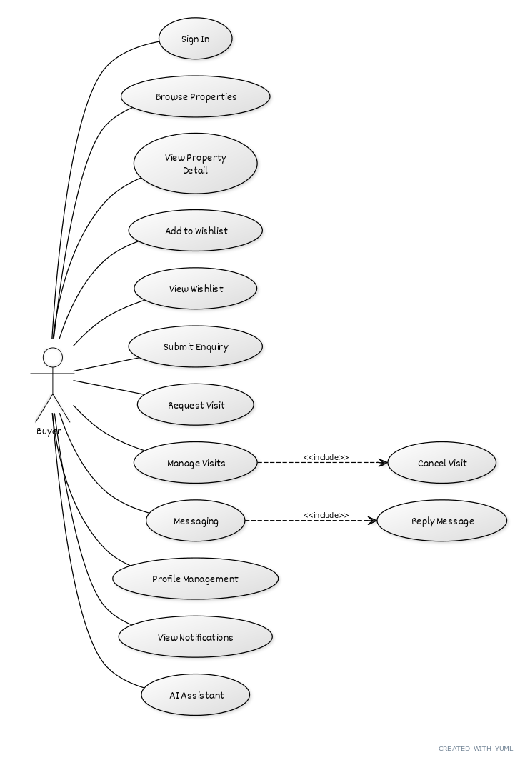

* Seller

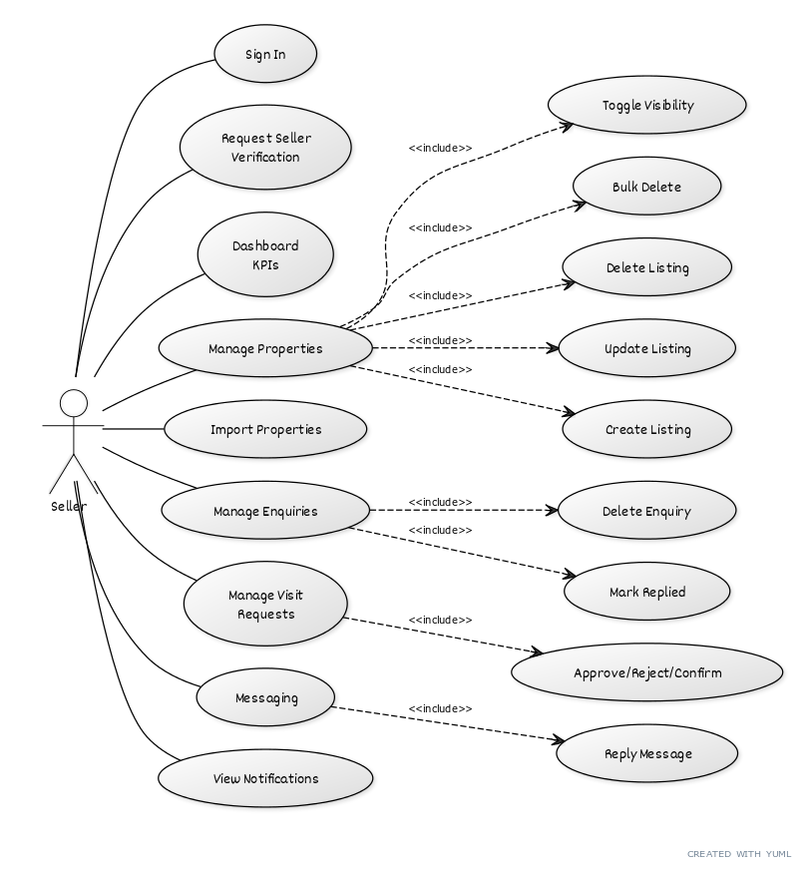

* Admin

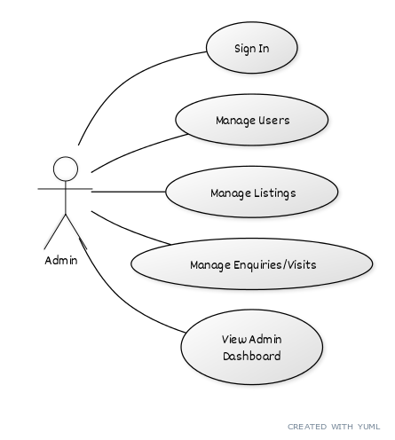

3.2 Class Diagram

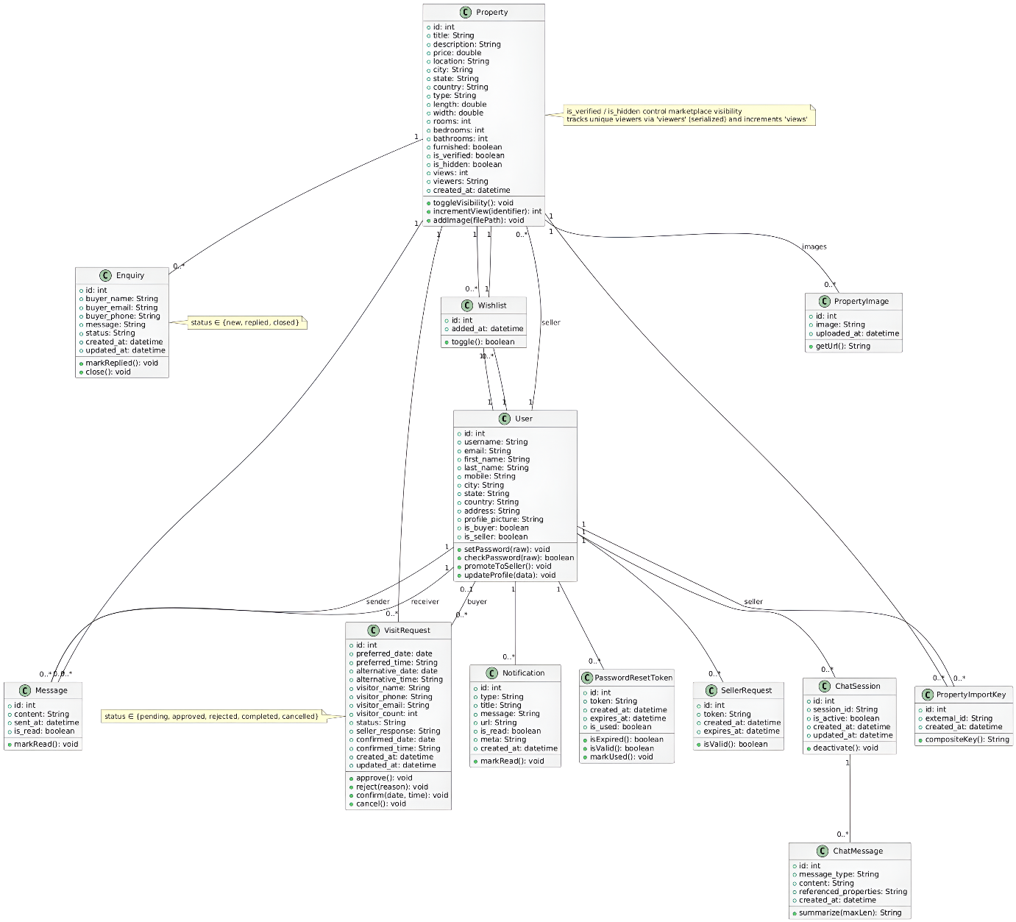

3.3 Interaction Diagram

* Property Search And Visit

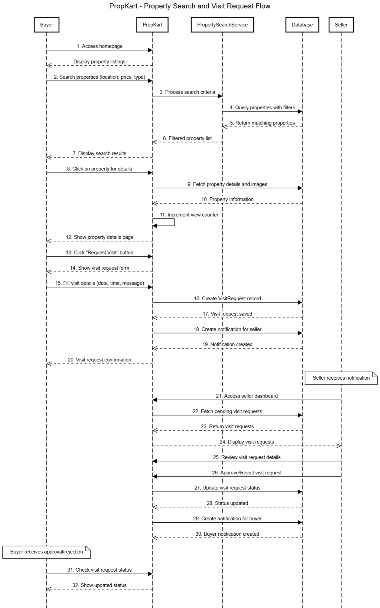

* Seller Request, Property Creation & Management

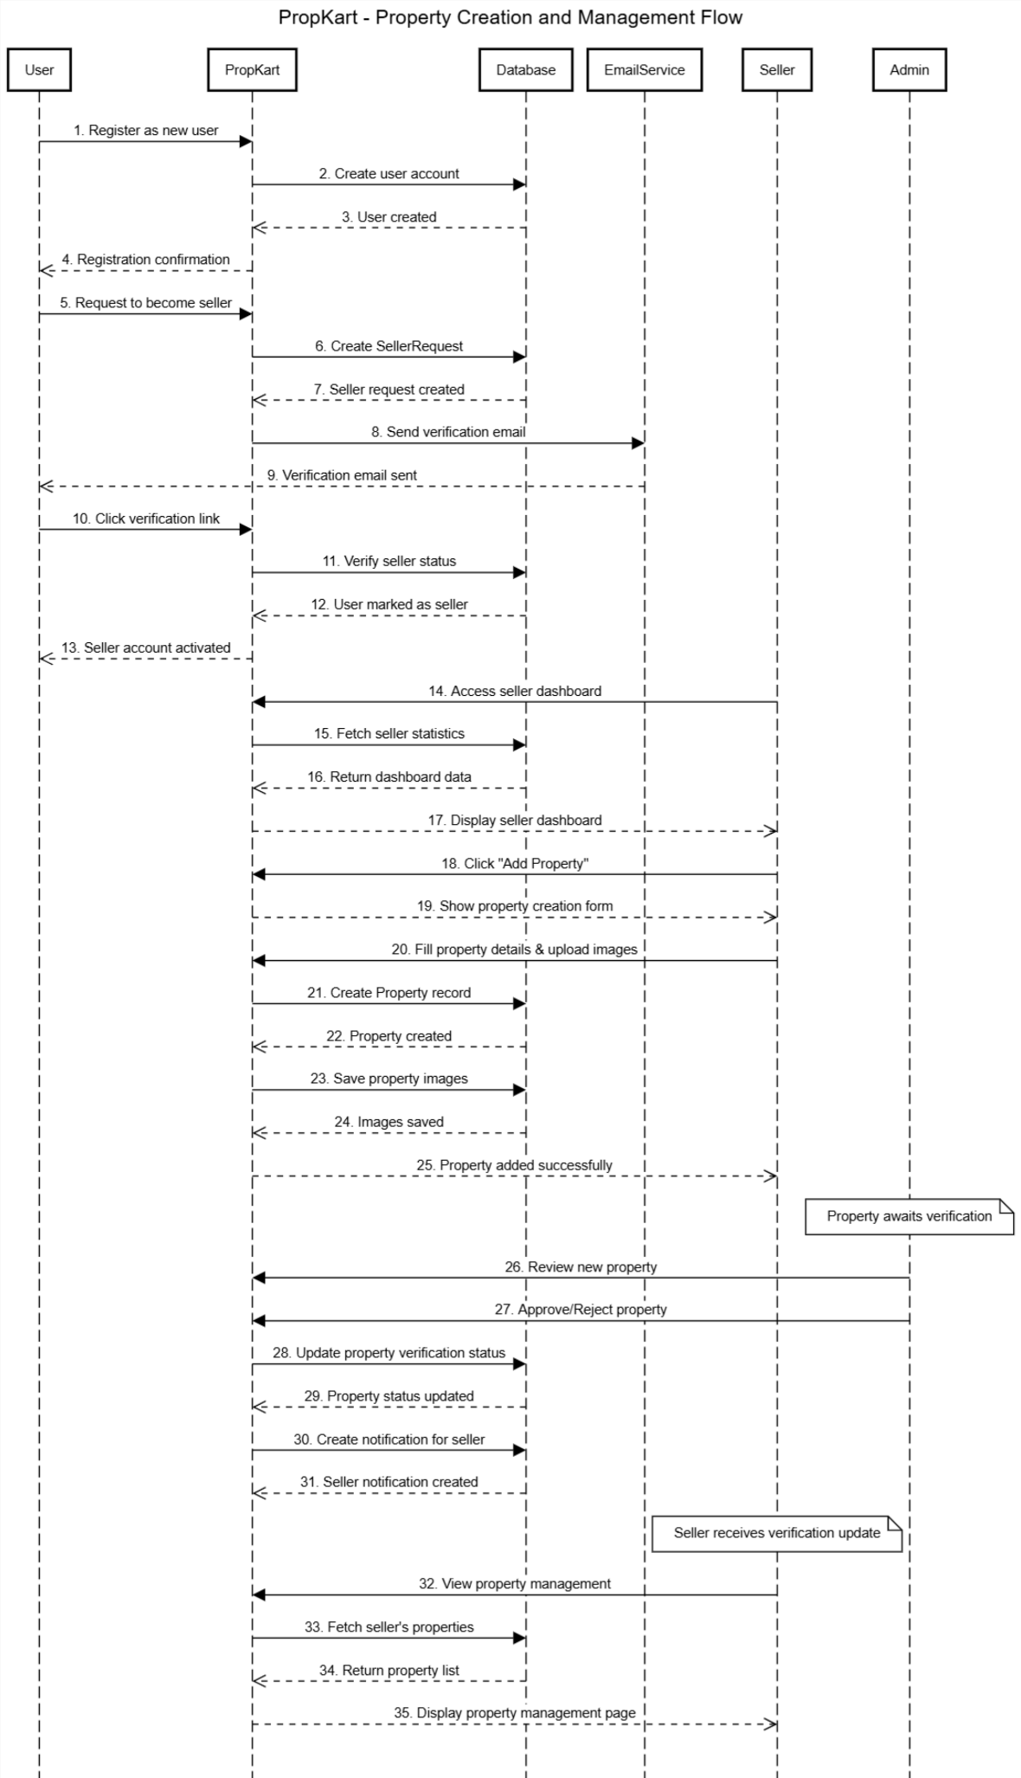

* User Registration & Authentication

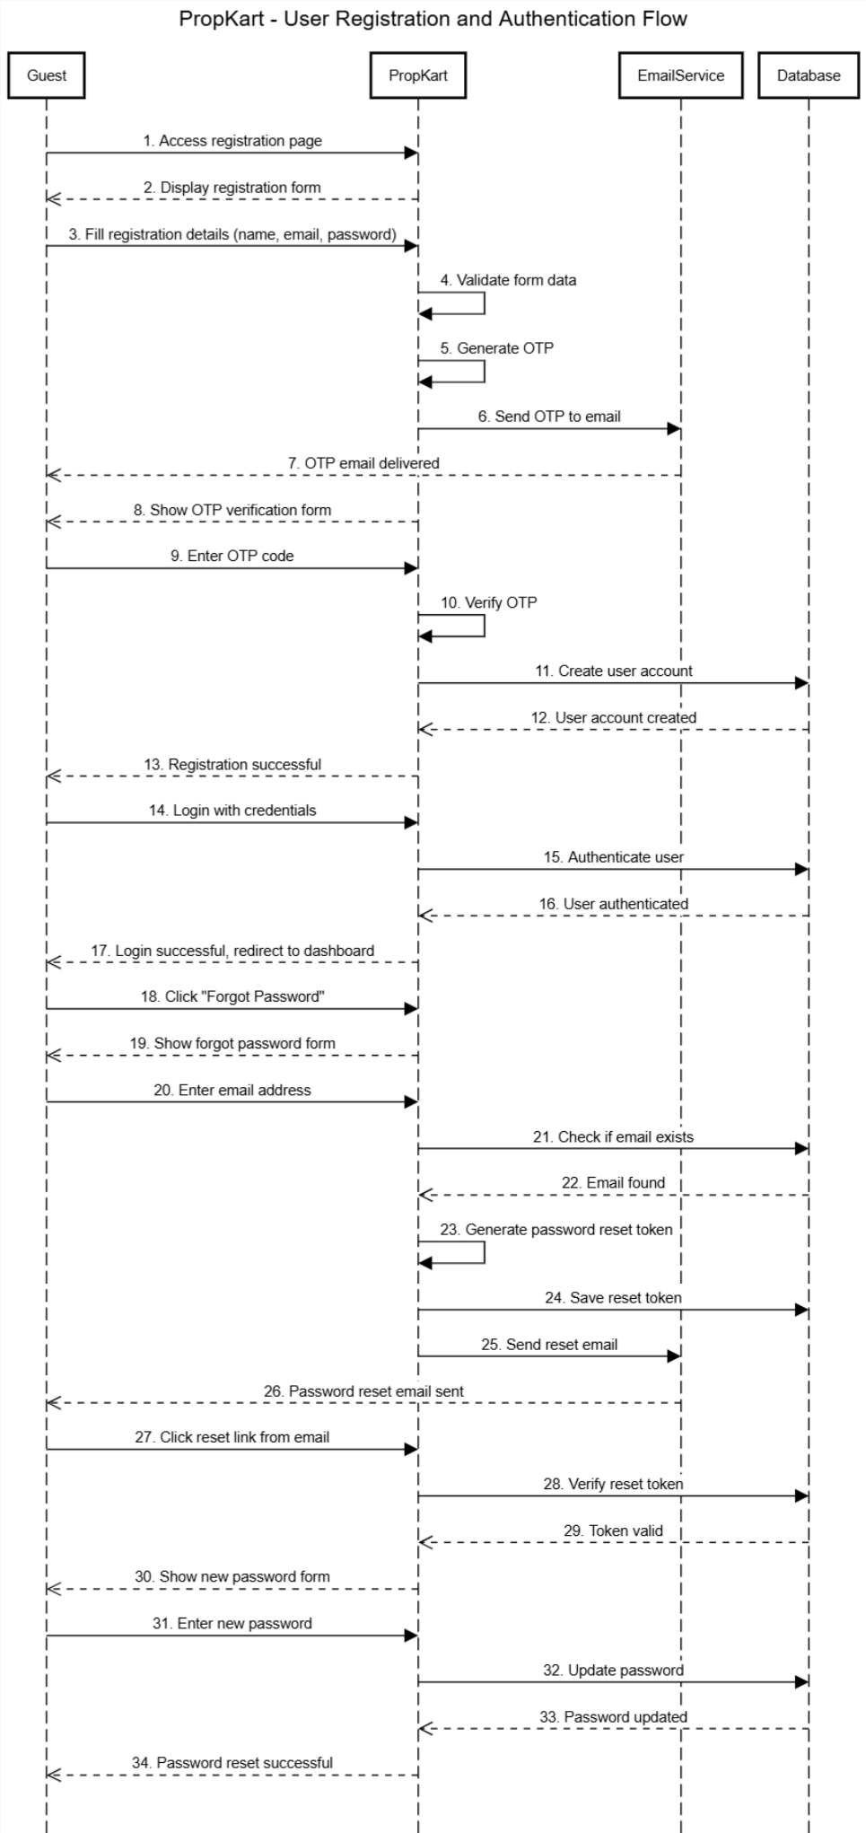

* AI Chat Assistant & Messaging System

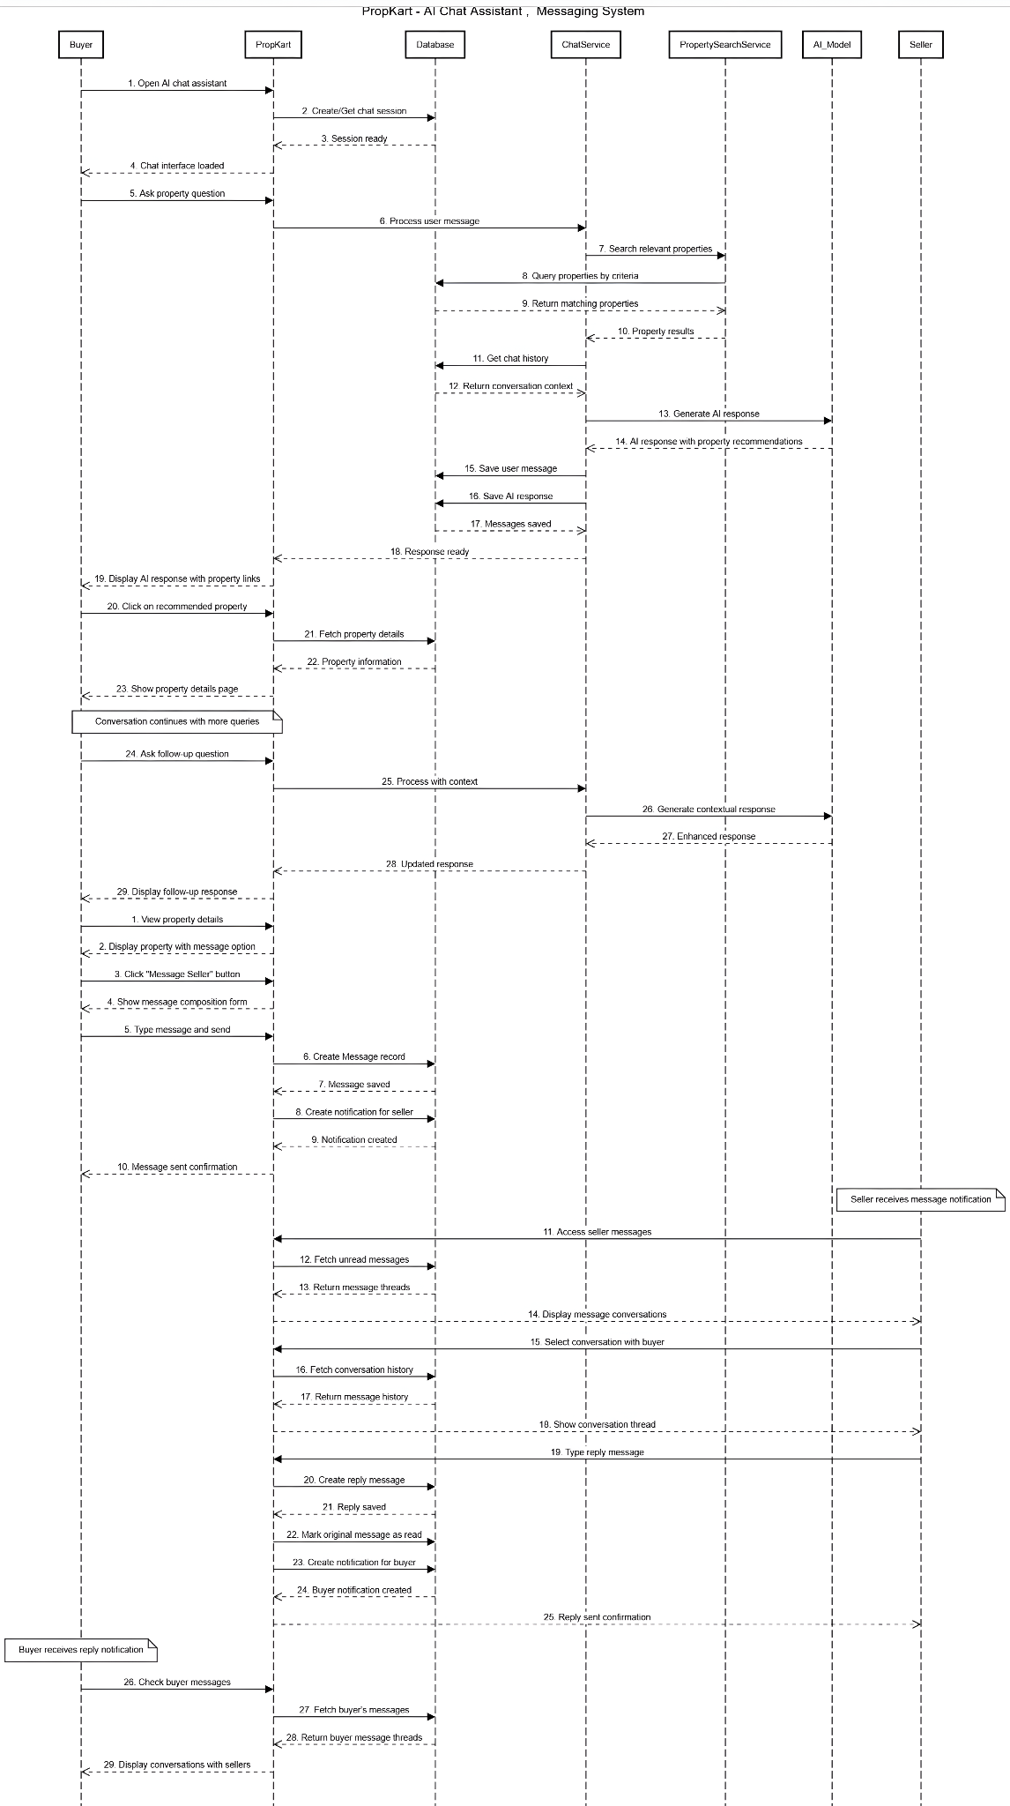

3.4 Activity Diagrams

* User Onboarding (Registration + Email OTP + Login)

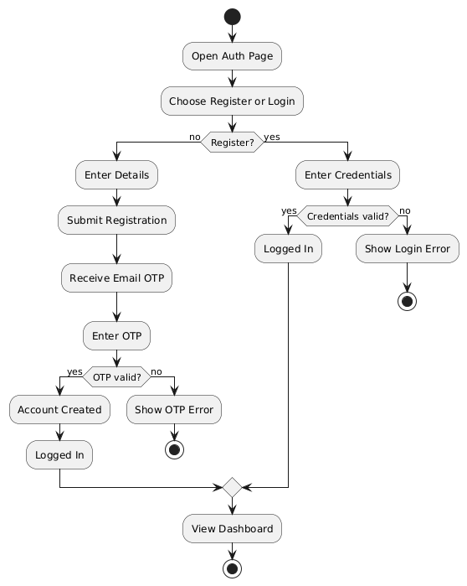

* Account Recovery (Password Reset via OTP)

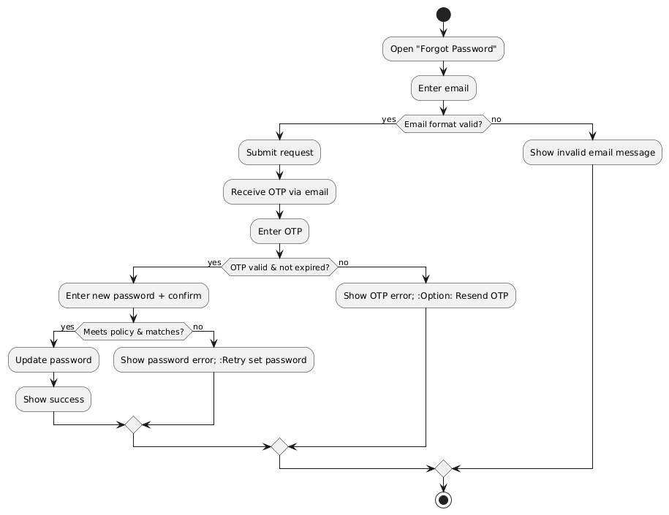

* Seller Enablement (Request + Email Verification)

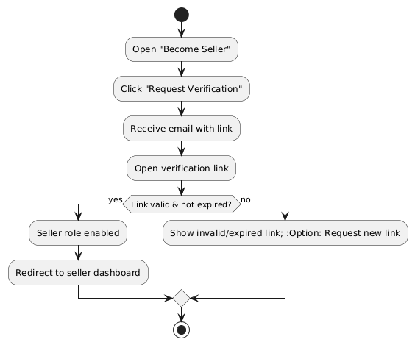

* Property Discovery (Browse + View Details)

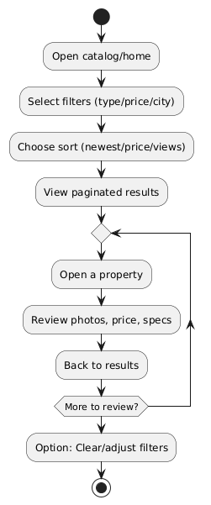

* Buyer Engagement (Wishlist + Enquiry + Messaging)

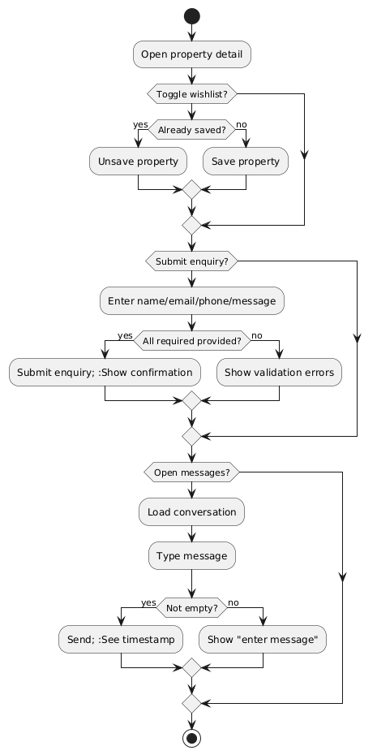

* Visit Lifecycle (Request + Decision + Optional Cancel)

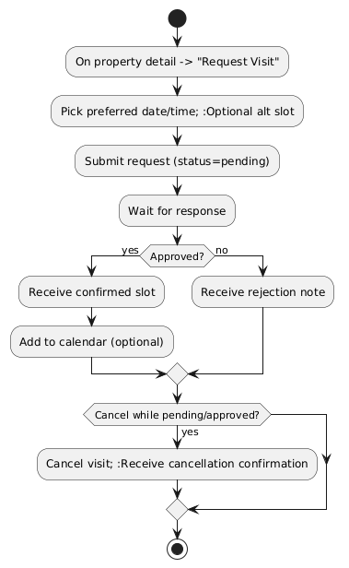

* Seller Listing Management (Create/Update/Delete/Bulk)

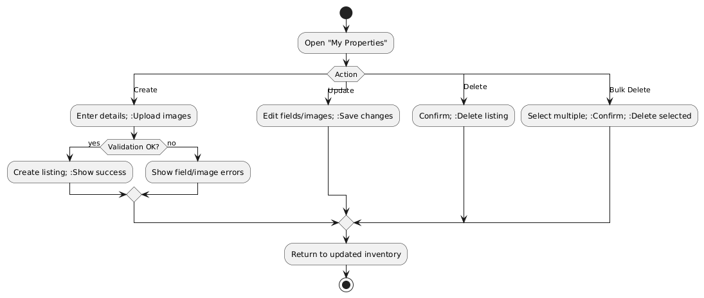

* Bulk Ingestion (CSV + ZIP Import)

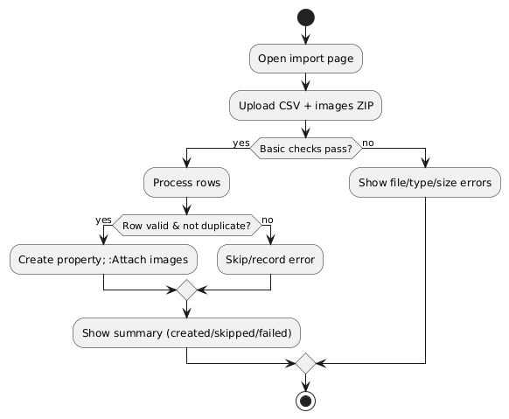

3.5 Data Dictionary

**3.1 User**

|  |  |  |  |
| --- | --- | --- | --- |
| Field | Type | Constraints | Description |
| id | BigAutoField | PK | User identifier |
| username | String(150) | Unique, Required | Login name |
| email | Email | Unique, Required | Primary email |
| first_name | String(150) | Optional | Given name |
| last_name | String(150) | Optional | Surname |
| mobile | String(15) | Optional | Phone number |
| city | String(50) | Optional | City |
| state | String(50) | Optional | State |
| country | String(50) | Optional | Country |
| address | Text | Optional | Address |
| profile_picture | Image | Optional | Avatar stored in media/profile_pics |
| is_buyer | Boolean | Default True | Buyer role flag |
| is_seller | Boolean | Default False | Seller role flag |

**3.2 Property**

|  |  |  |  |
| --- | --- | --- | --- |
| Field | Type | Constraints | Description |
| id | **AutoField** | **PK** | **Property identifier** |
| seller | **FK(User)** | **Required, CASCADE** | **Owner (seller)** |
| title | **String(100)** | **Required** | **Listing title** |
| description | **Text** | **Optional** | **Description** |
| price | **Decimal(12,2)** | **Required** | **Price** |
| location | **String(255)** | **Required** | **Address/location line** |
| city | **String(50)** | **Required** | **City** |
| state | **String(50)** | **Required** | **State** |
| country | **String(50)** | **Required** | **Country** |
| type | **Enum(apartment, house, land, villa, commercial)** | **Required** | **Property type** |
| length | **Decimal(10,2)** | **Optional** | **Length** |
| width | **Decimal(10,2)** | **Optional** | **Width** |
| rooms | **Integer** | **Optional** | **Rooms** |
| bedrooms | **Integer** | **Optional** | **Bedrooms** |
| bathrooms | **Integer** | **Optional** | **Bathrooms** |
| furnished | **Boolean** | **Default False** | **Furnishing flag** |
| created_at | **DateTime** | **Auto add** | **Created timestamp** |
| is_verified | **Boolean** | **Default False** | **Admin/ops verified** |
| is_hidden | **Boolean** | **Default False** | **Hidden from buyers** |
| views | **Integer** | **Default 0** | **View count** |
| viewers | **JSON** | **Default []** | **Unique viewer identifiers** |

**3.3 PropertyImage**

|  |  |  |  |
| --- | --- | --- | --- |
| Field | Type | Constraints | Description |
| id | AutoField | PK | Image id |
| property | FK(Property) | Required, CASCADE | Related listing |
| image | Image | Required | Stored in media/property_images |
| uploaded_at | DateTime | Auto add | Upload time |

**3.4 PropertyImportKey**

|  |  |  |  |
| --- | --- | --- | --- |
| Field | Type | Constraints | Description |
| id | AutoField | PK | Key id |
| seller | FK(User) | Required | Seller scope |
| external_id | String(100) | Required | External source id |
| property | FK(Property) | Required | Created property |
| created_at | DateTime | Auto add | Created time |
| unique_together | (seller, external_id) | — | Dedupe per seller |

**3.5 PasswordResetToken**

|  |  |  |  |
| --- | --- | --- | --- |
| Field | Type | Constraints | Description |
| id | Auto | PK | Token id |
| user | FK(User) | Required | Target user |
| token | String(6) | Unique, Required | 6-digit OTP |
| created_at | DateTime | Auto add | Created time |
| expires_at | DateTime | Required | Expiry |
| is_used | Boolean | Default False | Consumption flag |

**3.6 Wishlist**

|  |  |  |  |
| --- | --- | --- | --- |
| Field | Type | Constraints | Description |
| id | Auto | PK | Wishlist id |
| user | FK(User) | Required | Owner |
| property | FK(Property) | Required | Saved listing |
| added_at | DateTime | Auto add | When added |
| unique_together | (user, property) | — | One save per user/listing |

**3.7 Message**

|  |  |  |  |
| --- | --- | --- | --- |
| Field | Type | Constraints | Description |
| id | Auto | PK | Message id |
| sender | FK(User) | Required | From user |
| receiver | FK(User) | Required | To user |
| property | FK(Property) | Required | Thread context |
| content | Text | Required | Message body |
| sent_at | DateTime | Auto add | Sent time |
| is_read | Boolean | Default False | Read flag |

**3.8 VisitRequest**

|  |  |  |  |
| --- | --- | --- | --- |
| Field | Type | Constraints | Description |
| id | Auto | PK | Visit id |
| property | FK(Property) | Required | Target listing |
| buyer | FK(User) | Optional | Buyer (nullable for guest) |
| preferred_date | Date | Required | Preferred date |
| preferred_time | Time | Required | Preferred time |
| alternative_date | Date | Optional | Alternate date |
| alternative_time | Time | Optional | Alternate time |
| visitor_name | String(100) | Required | Contact name |
| visitor_phone | String(15) | Required | Contact phone |
| visitor_email | Email | Required | Contact email |
| message | Text | Optional | Notes |
| visitor_count | Integer | Default 1 | Party size |
| status | Enum(pending, approved, rejected, completed, cancelled) | Default pending | Current status |
| seller_response | Text | Optional | Seller note |
| confirmed_date | Date | Optional | Final date |
| confirmed_time | Time | Optional | Final time |
| created_at | DateTime | Auto add | Created |
| updated_at | DateTime | Auto now | Updated |

**3.9 Enquiry**

|  |  |  |  |
| --- | --- | --- | --- |
| Field | Type | Constraints | Description |
| id | Auto | PK | Enquiry id |
| property | FK(Property) | Required | Listing |
| buyer_name | String(100) | Required | Name |
| buyer_email | Email | Required | Email |
| buyer_phone | String(15) | Required | Phone |
| message | Text | Required | Message |
| status | Enum(new, replied, closed) | Default new | Status |
| created_at | DateTime | Auto add | Created |
| updated_at | DateTime | Auto now | Updated |

**3.10 Notification**

|  |  |  |  |
| --- | --- | --- | --- |
| Field | Type | Constraints | Description |
| id | Auto | PK | Notification id |
| user | FK(User) | Required | Recipient |
| type | String(50) | Required | Category (chat, enquiry, visit, etc.) |
| title | String(120) | Required | Title |
| message | Text | Optional | Body |
| url | String(255) | Optional | Deep link |
| is_read | Boolean | Default False | Read flag |
| meta | JSON | Default {} | Extra data |
| created_at | DateTime | Auto add | Created |

**3.11 ChatSession**

|  |  |  |  |
| --- | --- | --- | --- |
| Field | Type | Constraints | Description |
| id | Auto | PK | Session id |
| user | FK(User) | Required | Owner |
| session_id | UUID | Unique, Required | Public session key |
| created_at | DateTime | Auto add | Created |
| updated_at | DateTime | Auto now | Updated |
| is_active | Boolean | Default True | Active session flag |

**3.12 ChatMessage**

|  |  |  |  |
| --- | --- | --- | --- |
| Field | Type | Constraints | Description |
| id | Auto | PK | Chat message id |
| session | FK(ChatSession) | Required | Session |
| message_type | Enum(user, assistant) | Required | Role |
| content | Text | Required | Message text |
| referenced_properties | JSON | Default [] | Related property ids |
| created_at | DateTime | Auto add | Created |

**3.13 SellerRequest**

|  |  |  |  |
| --- | --- | --- | --- |
| Field | Type | Constraints | Description |
| id | Auto | PK | Request id |
| user | FK(User) | Required | Requestor |
| token | UUID | Unique, Required | Verification token |
| created_at | DateTime | Auto add | Created |
| expires_at | DateTime | Required | Expiry timestamp |

**4. Development**

**4.1 Coding Standards**

**1. Naming Conventions**

* Class names: PascalCase (e.g., User, Property, VisitRequest)
* Method and variable names: snake_case (e.g., get_user_details, property_list)
* Constants: UPPER_SNAKE_CASE (e.g., MAX_IMAGE_SIZE, ALLOWED_FILE_TYPES)
* Model fields: snake_case (e.g., first_name, is_verified, created_at)

**2. Comments and Documentation**

* Code should be well-commented, especially for complex business logic
* Use Django docstrings for views, models, and utility functions
* Document API endpoints with clear parameter descriptions
* Comment complex queries and database operations

**3. Django Views and Controllers**

* Each view should handle a single HTTP request/response cycle
* Follow Django's function-based or class-based view patterns
* Use decorators for authentication (@modal_login_required)
* Implement proper error handling and user feedback via messages

**4. URL Routing**

* Use descriptive URL patterns (e.g., property/<int:property_id>/, seller/dashboard)
* Organize routes logically by feature (auth/, seller/, buyer/, api/)
* Use HTTP methods appropriately (GET for views, POST for actions)
* Implement URL names for reverse lookups

**5. Templates and Frontend**

* Use Django template inheritance with base templates
* Component-based template structure (base.html, seller/, buyer/)
* Maintain clean HTML with Bootstrap classes
* Use JavaScript for interactive features (modals, AJAX, form validation)
* Separate static assets (CSS/JS) into organized directories

**6. Database and Models**

* Use Django migrations for all schema changes
* Follow normalized table structures with proper foreign key relationships
* Implement model methods for business logic (e.g., is_valid(), toggle())
* Use appropriate field types and constraints
* Add database indexes for performance optimization

**7. Testing**

* Write unit tests for models and utility functions
* Implement view tests for critical user flows
* Test authentication and authorization scenarios
* Perform integration tests for complex workflows (enquiries, visits, messaging)
* Use Django's test client for HTTP request testing

**8. Security and Best Practices**

* Validate all user inputs to prevent injection attacks
* Use Django's CSRF protection for forms
* Implement proper authentication and authorization checks
* Sanitize file uploads (type, size validation)
* Use Django's built-in security features (XSS protection, SQL injection prevention)
* Implement rate limiting for sensitive operations (OTP requests)

**9. Error Handling**

* Use Django's messages framework for user feedback
* Implement graceful error handling for file operations
* Log errors appropriately for debugging
* Provide meaningful error messages to users
* Handle edge cases (expired tokens, missing files, invalid data)

**10. Performance Optimization**

* Use select_related() and prefetch_related() for database queries
* Implement pagination for large datasets
* Optimize image handling and storage
* Use database indexes for frequently queried fields
* Cache frequently accessed data where appropriate

**11. Code Organization**

* Separate concerns: models, views, templates, static files
* Use utility functions for common operations (delete_property_images)
* Implement service classes for complex business logic (ChatService)
* Keep views focused and delegate complex operations to models/services
* Maintain consistent file structure across the project

**12. Configuration Management**

* Use environment variables for sensitive settings
* Separate development and production configurations
* Implement proper media and static file handling
* Use Django's settings system for feature flags and configurations

**4.2 Screenshots**

**Sign Up Section**

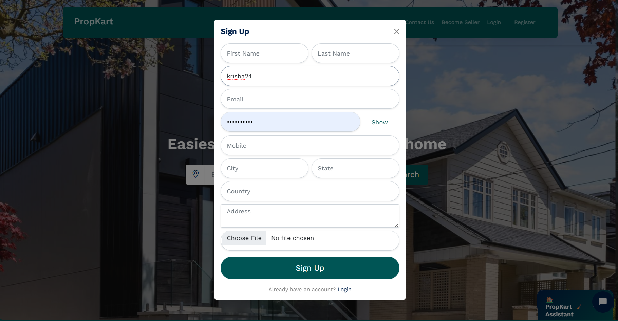

**Screen: A Sign Up modal overlaying the property search page of the PropKart web app.**

**Main content:**

* **A Sign Up modal window is displayed centrally, titled "Sign Up".**
* **The form requires several fields for user registration:**
  + **First Name and Last Name.**
  + **Username**
  + **Email.**
  + **Password**
  + **Mobile.**
  + **City and State.**
  + **Country.**
  + **Address (text area).**
  + **Profile Photo upload with a "Choose File" button.**
* **The background shows the main property search page with a blurred hero section.**

**Actions:**

* **A primary "Sign Up" button (dark green) to submit the registration form.**
* **A "Login" link at the bottom for users who already have an account.**
* **A close (X) icon in the top-right corner of the modal to dismiss the form.**

**Log in Section**

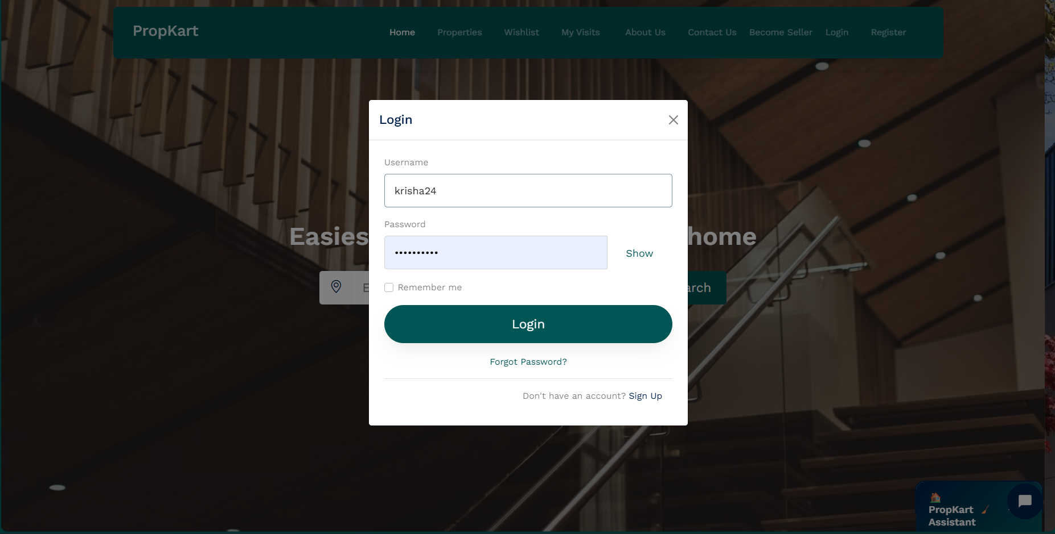

**Screen: A Login modal overlaying the property search page of the PropKart web app.**

**Main content:**

* **A Login modal window is displayed centrally, titled "Login".**
* **The form contains two input fields: Username and Password (masked, with a "Show" link).**
* **A "Remember me" checkbox is included below the inputs.**
* **The background shows the main property search page (similar to the image you previously described) with a blurred hero section, highlighting the "Easiest way to find your next home" message.**

**Actions:**

* **A primary "Login" button (dark green) to submit credentials.**
* **A "Forgot Password?" link below the login button.**
* **A "Sign Up" link for users who do not have an account.**
* **A close (X) icon in the top-right corner of the modal to dismiss the form.**

**Forgot Password Section**

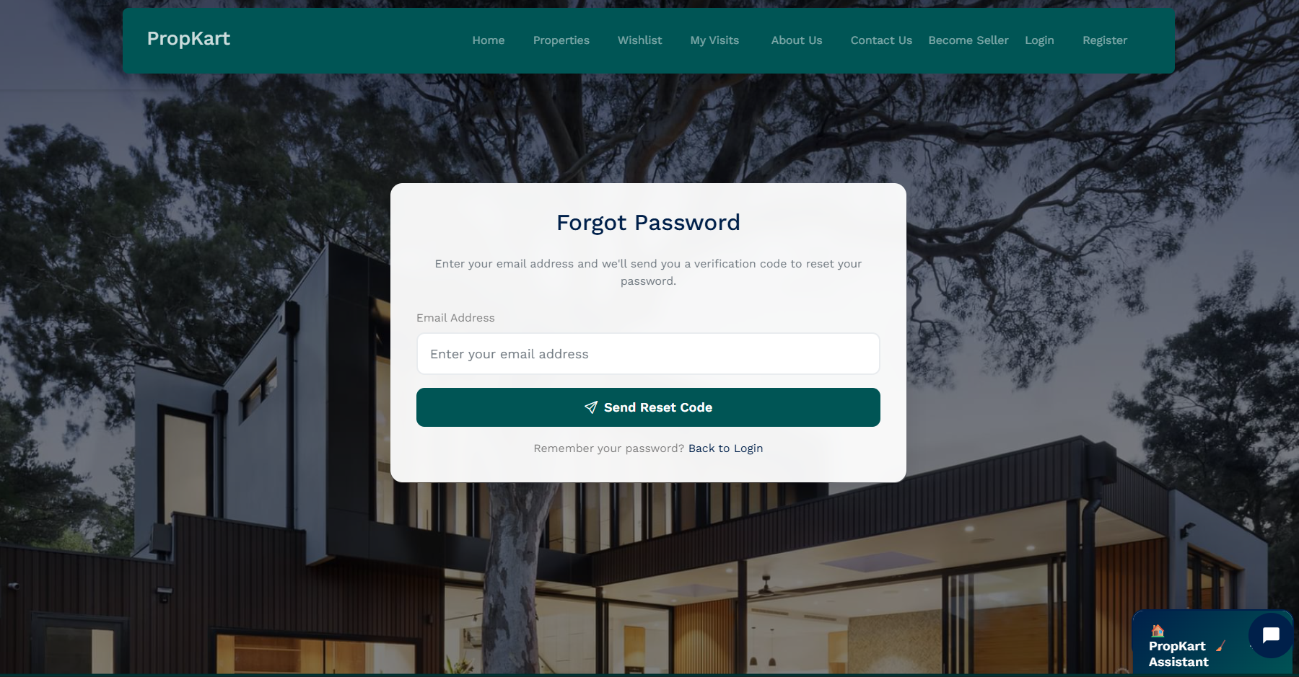

**Screen: A "Forgot Password" modal overlaying the property search page.**

**Main content:**

* **A modal window titled "Forgot Password".**
* **Instructional text: "Enter your email address and we'll send you a verification code to reset your password."**
* **A single input field for "Email Address".**
* **The background shows the main property search page with a blurred hero section and header for a logged-out user (showing Login/Register).**

**Actions:**

* **A primary "Send Reset Code" button (dark green) to submit the email address.**
* **A "Back to Login" link for users who remember their password.**
* **A close (X) icon in the top-right corner of the modal to dismiss the form.**

**Verify OTP Section**

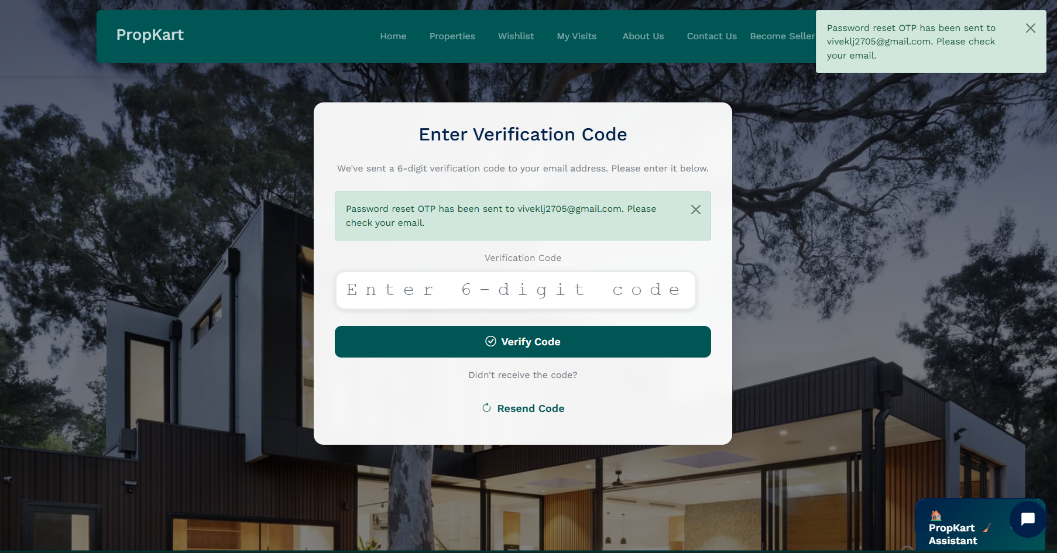

**Screen: A Verification Code modal overlaying the property search page after a password reset request.**

**Main content:**

* **A modal window titled "Enter Verification Code".**
* **Instructional text: "We've sent a 6-digit verification code to your email address. Please enter it below."**
* **A success message banner inside the modal confirms: "Password reset OTP has been sent to vivek.lj2705@gmail.com. Please check your email."**
* **An input field for the Verification Code (prompting "Enter 6-digit code").**
* **A global success notification toast is visible in the top-right corner, also stating: "Password reset OTP has been sent to vivek.lj2705@gmail.com. Please check your email."**
* **The background shows the main property search page with a blurred hero section and header for a logged-out user (showing Login/Register).**

**Actions:**

* **A primary "Verify Code" button (dark green) to submit the 6-digit code.**
* **A "Resend Code" link for users who did not receive the code.**
* **A close (X) icon in the top-right corner of the modal to dismiss the form.**

**Reset Password Section**

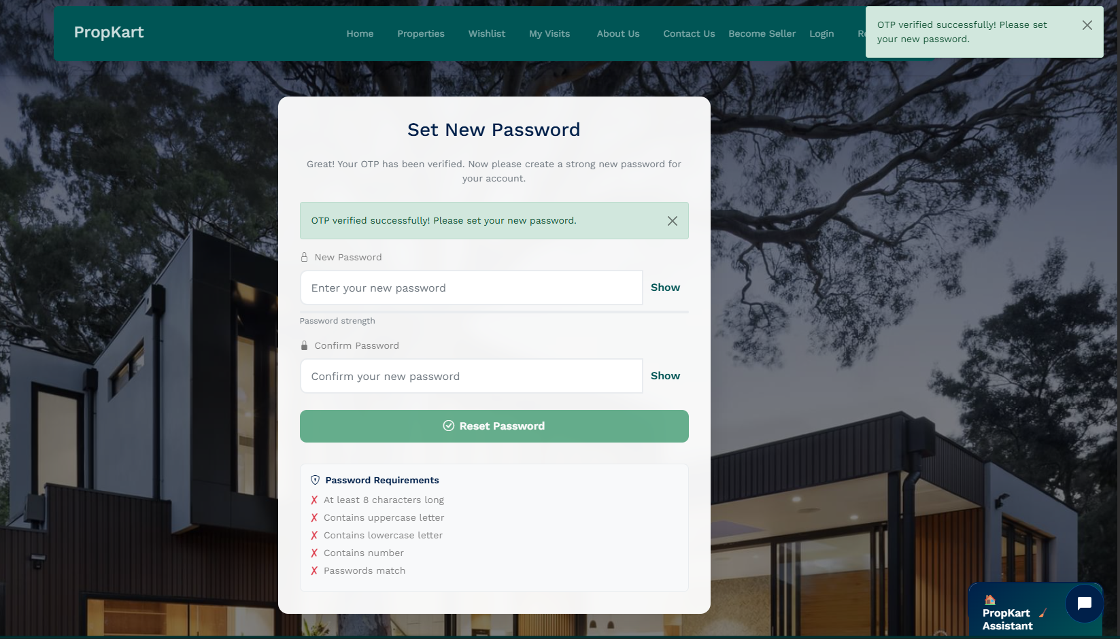

**Screen: A "Set New Password" modal overlaying the property search page after successful OTP verification.**

**Main content:**

* **A modal window titled "Set New Password".**
* **Instructional text: "Great! Your OTP has been verified. Now please create a strong new password for your account."**
* **A banner confirms: "OTP verified successfully! Please set your new password."**
* **Input fields for New Password and Confirm Password (both masked, with a "Show" link).**
* **A "Password strength" indicator is visible.**
* **A section lists Password Requirements (e.g., At least 8 characters long, Contains uppercase letter, etc.), which appear to be currently unfulfilled (marked with red crosses).**

**Actions:**

* **A primary "Reset Password" button (green) to submit the new password.**
* **A close (X) icon in the top-right corner of the modal to dismiss the form.**

**Home Page**

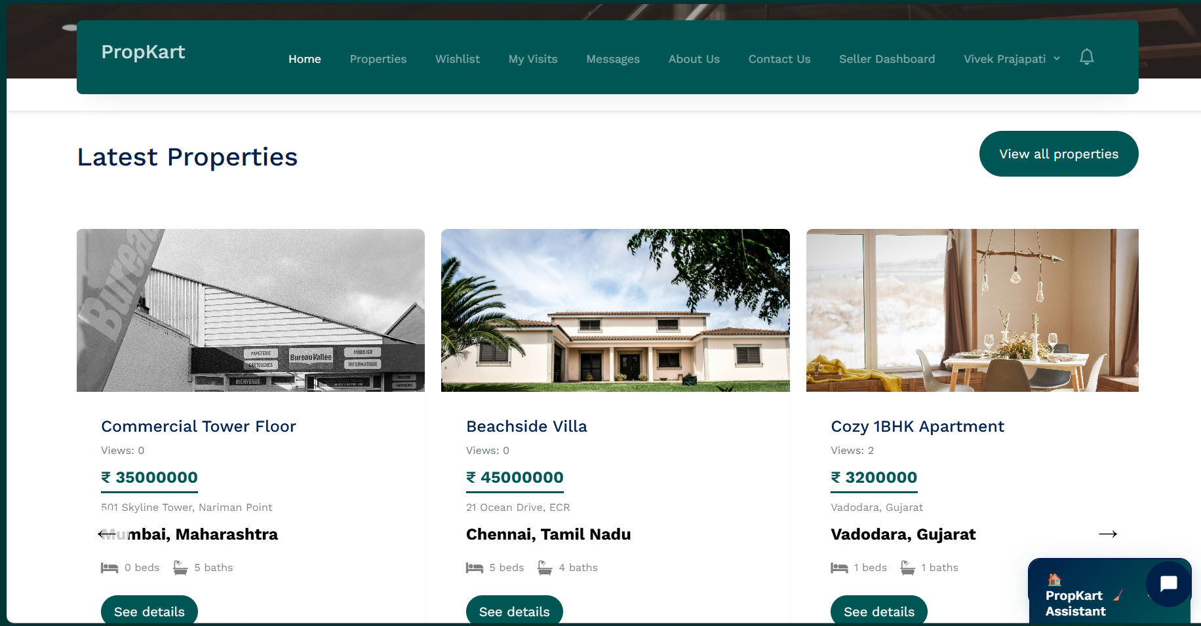

**Screen: “Latest Properties” listing page of the PropKart real-estate web app.**

Header:

* Top **navigation bar** displaying the brand **PropKart**.
* Primary menu links: **Home, Properties, Wishlist, My Visits, Messages, About Us, Contact Us, Seller Dashboard**.
* User profile and **notifications** icon.

Main content:

* Section titled **"Latest Properties"**.
* A **three-card grid** showcasing recent listings.
* Each card includes a **thumbnail image, property title, views count, price (₹), address/city**, and icons for the number of **beds and baths**.

Actions:

* **"See details"** button on each property card to navigate to the individual property page.
* **"View all properties"** button positioned above the listings to open the full property search and listings page.

Extras:

* Floating chat/assistant widget in the **bottom-right** corner.

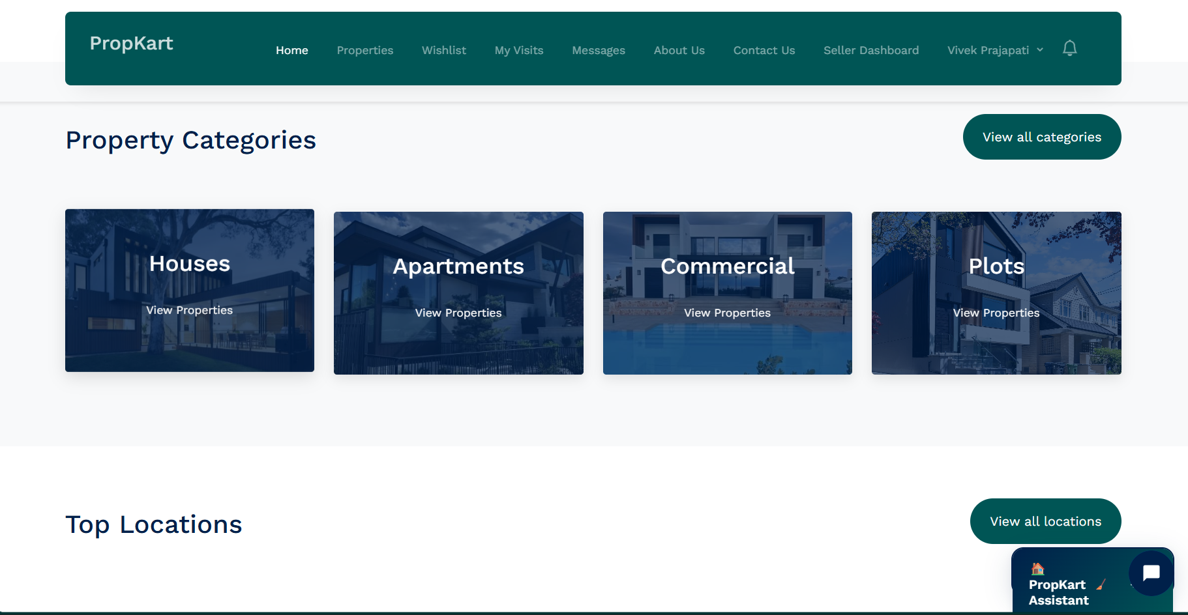

**Screen: "Property Categories" and beginning of the "Top Locations" section.**

Header:

* Top navigation bar with the brand **PropKart**.
* Primary menu links: **Home, Properties, Wishlist, My Visits, Messages, About Us, Contact Us, Seller Dashboard**.
* User profile and a notification icon.

Main content:

* Section titled **"Property Categories"**.
* A grid of four cards for major property types: **Houses, Apartments, Commercial, and Plots**.
* Each category card features a background image, the category name, and a "View Properties" button.
* The title for the next section, **"Top Locations"**, is visible at the bottom.

Actions:

* **"View all categories"** button to view a complete list of categories.
* **"View Properties"** button on each category card to navigate to filtered listings.
* **"View all locations"** button next to the "Top Locations" heading.

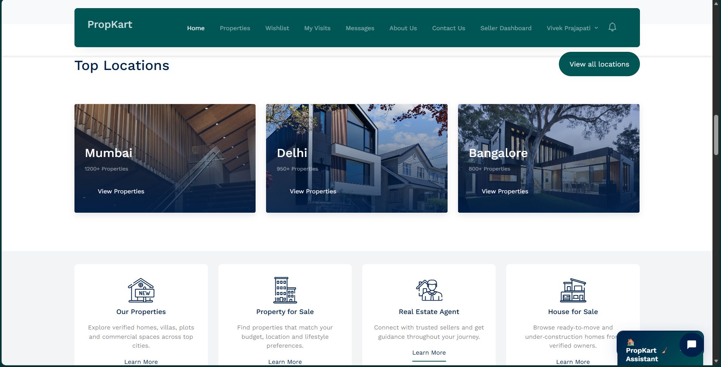

**Screen: "Top Locations" section with featured services on the PropKart real-estate web app.**

Header:

* Top **navigation bar** displaying the brand **PropKart**.
* Primary menu links: **Home, Properties, Wishlist, My Visits, Messages, About Us, Contact Us, Seller Dashboard**.
* User profile and a notification icon.

Main content:

* Section titled **"Top Locations"**, featuring a grid of three large location cards: **Mumbai** (1200+ Properties), **Delhi** (950+ Properties), and **Bangalore** (800+ Properties).
* Below the location cards is a **four-column grid of featured services**, including **Our Properties, Property for Sale, Real Estate Agent, and House for Sale**. Each service has a title, an icon, a brief description, and a **"Learn More"** link.

Actions:

* **"View all locations"** button above the location cards to see a full list of cities.
* **"View Properties"** button on each location card to filter listings by that specific city.
* **"Learn More"** link beneath each featured service to access detailed information.

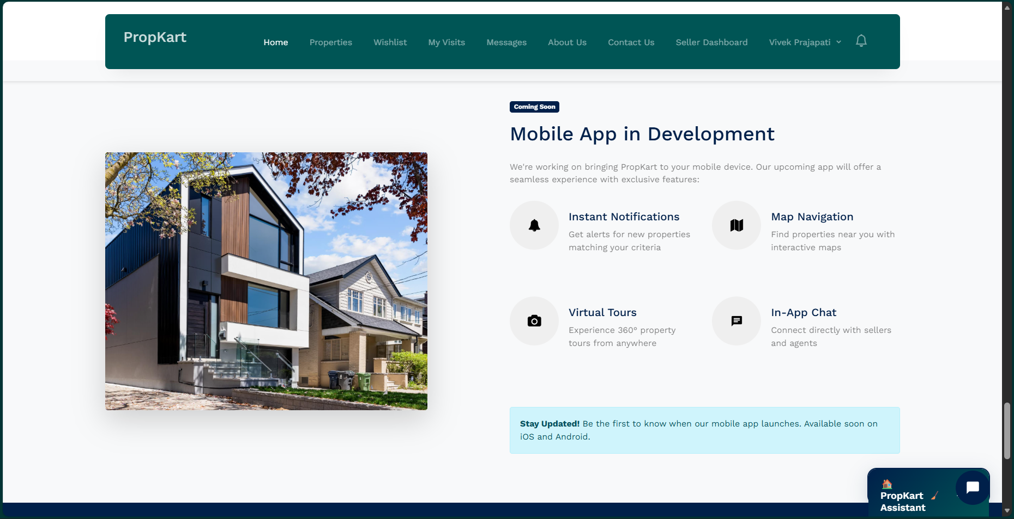

**Screen: "Mobile App in Development" announcement page on the PropKart web app.**

Header:

* Top **navigation bar** displaying the brand **PropKart**.
* Primary menu links: **Home, Properties, Wishlist, My Visits, Messages, About Us, Contact Us, Seller Dashboard**.
* User profile and a notification icon.

Main content:

* A central page dedicated to announcing the upcoming mobile application, titled **"Mobile App in Development"** with a **"Coming Soon"** tag.
* A large **image of a modern house** on the left.
* A description detailing the goal of a **"seamless experience"** with exclusive features.
* A list of key features presented with icons:
  + **Instant Notifications**
  + **Map Navigation**
  + **Virtual Tours**
  + **In-App Chat**
* A final update message: **"Stay Updated! Be the first to know when our mobile app launches. Available soon on iOS and Android."**

Actions:

* No primary interactive buttons other than the header navigation links. The focus is on providing information.

**PropKart Assistant [AI Chatbot]**

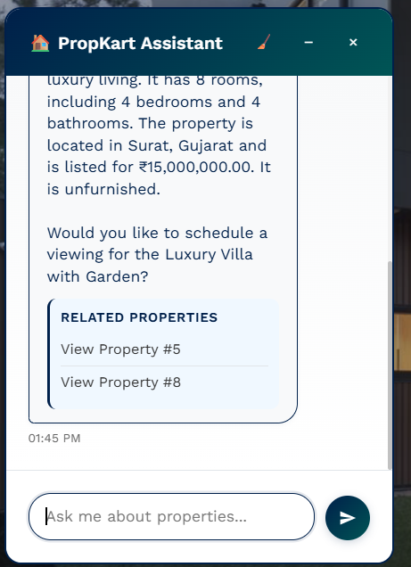

**Screen: The PropKart Assistant chat interface window displaying property information and related links.**

**Main content:**

* **The chat window is titled "PropKart Assistant".**
* **The assistant is providing a detailed description of a property, specifically the Luxury Villa with Garden.**
* **The property details include: rooms, bedrooms, bathrooms, location, price, and status.**
* **The assistant follows up with a call-to-action: "Would you like to schedule a viewing for the Luxury Villa with Garden?"**
* **A dedicated section titled "RELATED PROPERTIES" is displayed below the message.**
* **The related properties list contains two links: "View Property #5" and "View Property #8".**

**Actions:**

* **An input field labeled "Ask me about properties..." is available for user text entry.**
* **A Send button (paper airplane icon) to submit the user's message.**
* **Clicking the "View Property #5" or "View Property #8" links to navigate to those listings.**
* **Minimize/Maximize and Close (X) buttons are available for the chat window.**

**Properties Page**

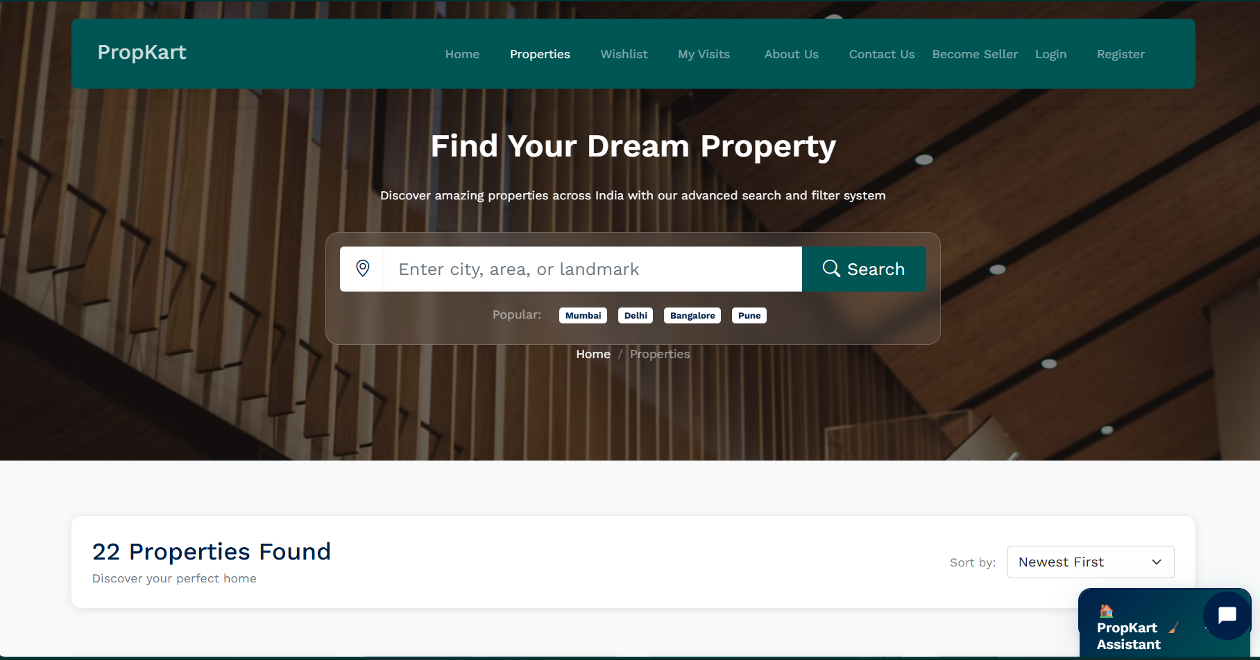

**Screen: The Properties search and filter page of the PropKart real-estate web app.**

Main content:

* A large background image overlayed by the main search interface.
* Main heading: **"Find Your Dream Property"**.
* Subtitle: "Discover amazing properties across India with our advanced search and filter system".
* A prominent **search bar** allowing users to "Enter city, area, or landmark" with a **Search button** and location icon.
* **Popular** search tags are listed below the search bar: **Mumbai, Delhi, Bengaluru, Pune**.
* A breadcrumb navigation path is visible: **Home / Properties**.
* Below the main hero section, a results summary shows: **"22 Properties Found"** with a description: "Discover your perfect home".

Actions:

* **"Search"** button to execute the property search.
* Clicking the **Popular** city tags (Mumbai, Delhi, etc.) to initiate a search for that location.
* A **Sort by** dropdown menu (currently showing **"Newest First"**) to arrange the property listings (though the listings themselves are not visible).

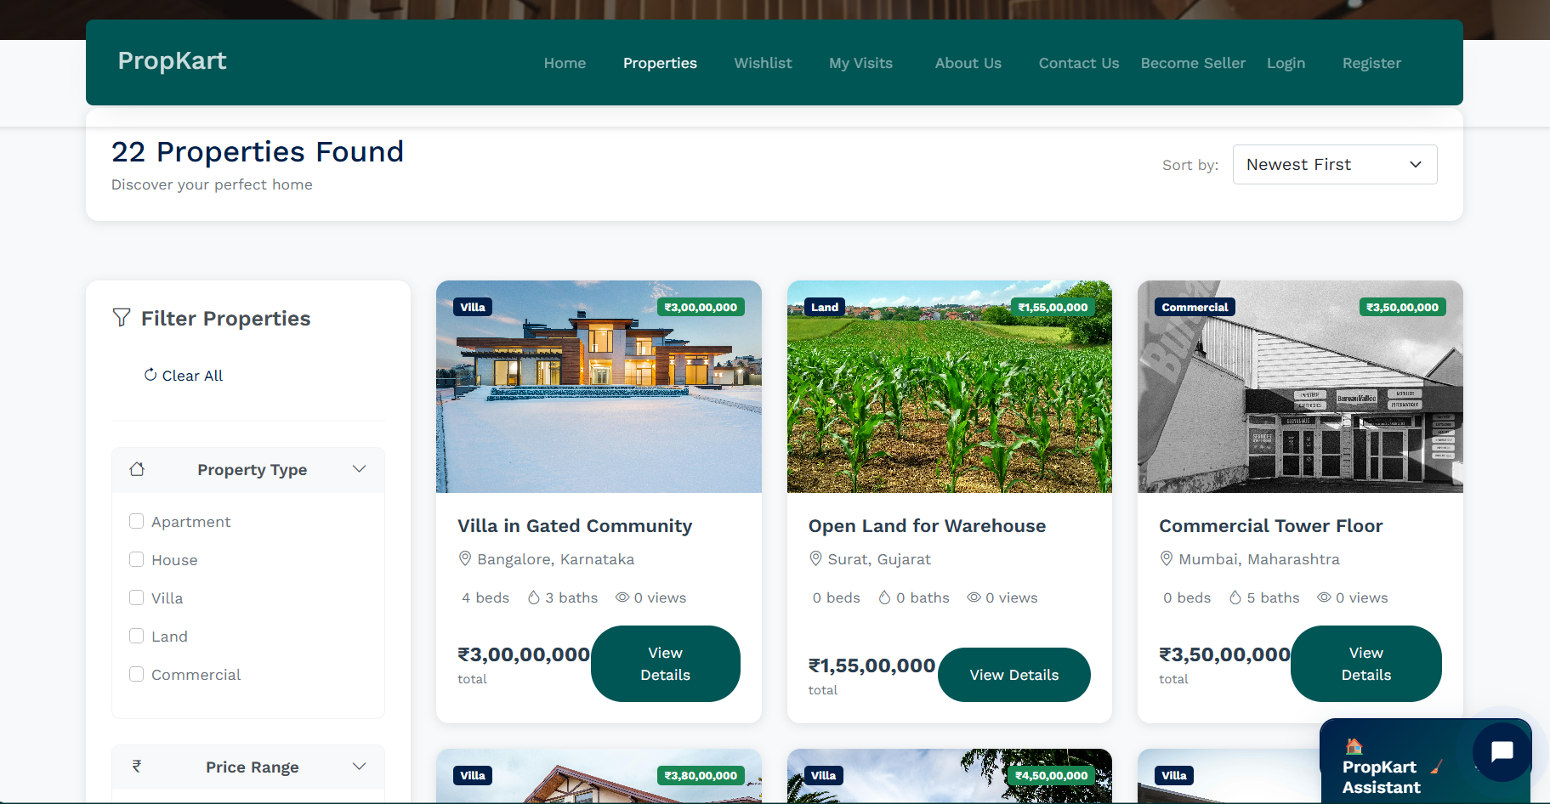

**Screen: Property Listings search results page on the PropKart real-estate web app, showing filters and property cards.**

Header:

* Top navigation bar with brand (**PropKart**), primary menus, and links for user actions (**Login, Register, Become Seller**).

Main content:

* Results summary section showing **"22 Properties Found"** and a **Sort by** dropdown menu (currently "Newest First").
* A left sidebar dedicated to **"Filter Properties"** starting with a **"Clear All"** link.
* The first filter section is **"Property Type"** (collapsed state is not visible, but the options are). Options include checkboxes for: **Apartment, House, Villa, Land, and Commercial**.
* The main display area shows a **three-column grid of property listing cards**.
  + Each card displays a thumbnail image, property type label (**Villa, Land, Commercial**), price, title, location (City, State), basic specs (beds/baths), views count, and a **"View Details"** button.
* The start of the next filter section, **"Price Range"**, is visible below the Property Type filter.

Actions:

* **"Clear All"** link to reset all active filters.
* Checkboxes in the filter sidebar to refine search results by property type.
* **"View Details"** button on each property card to navigate to the individual property page.
* **Sort by** dropdown menu to reorder the displayed listings.

**Wishlist Page**

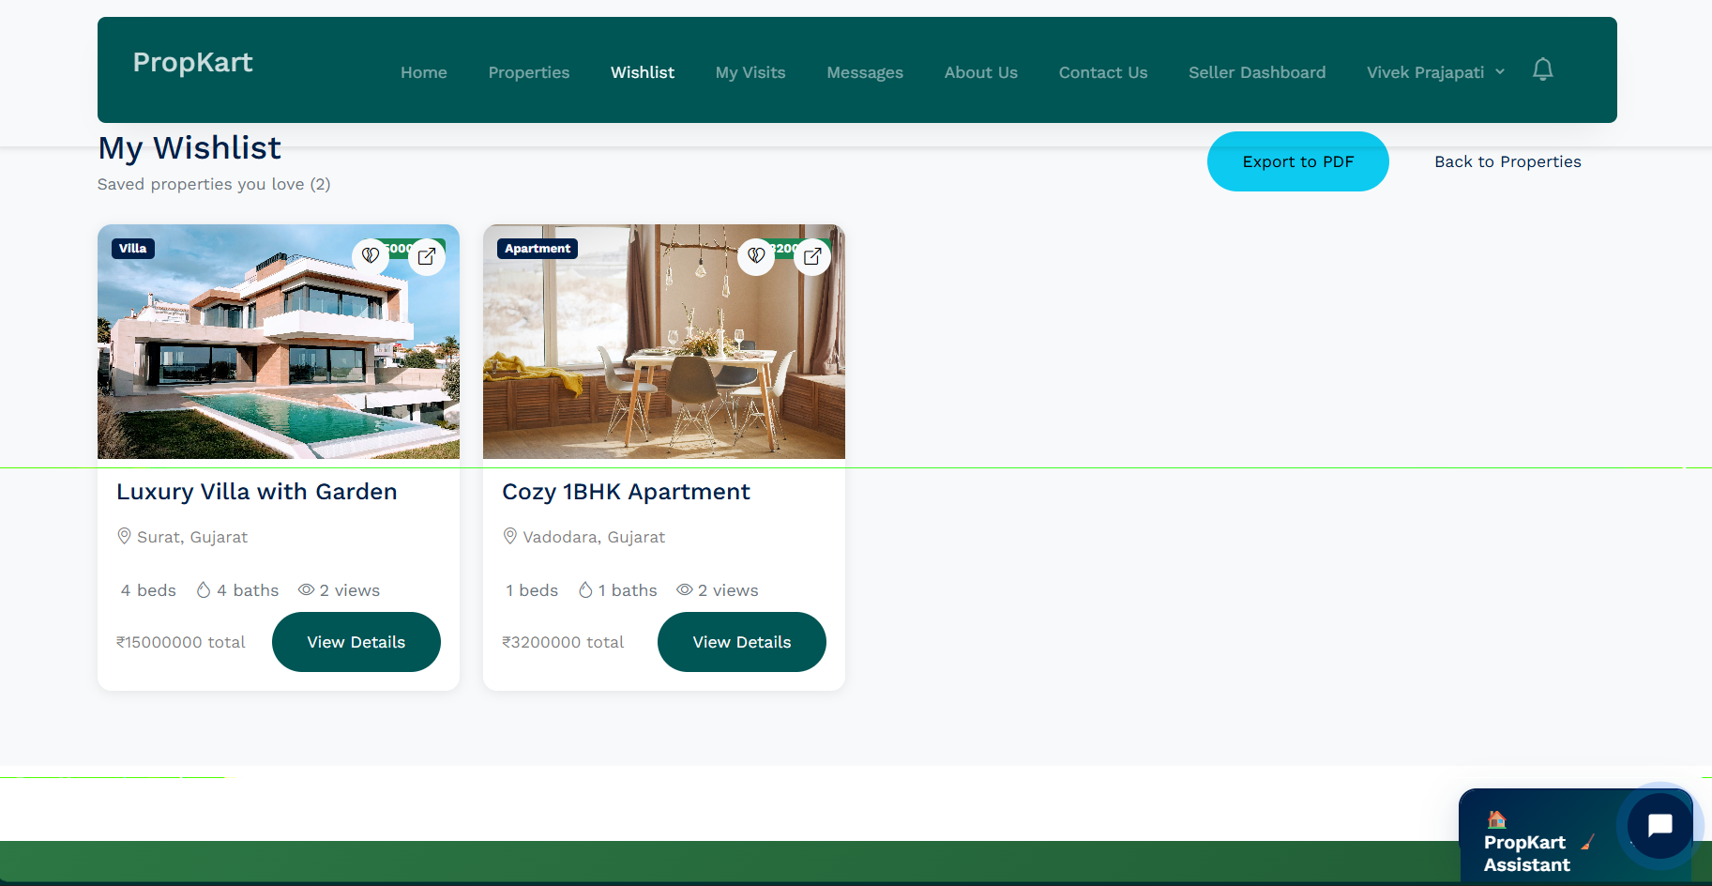

**Screen: The My Wishlist page displaying saved properties for a logged-in user on the PropKart web app.**

Header:

* Top navigation bar with brand (**PropKart**), primary menus (**Home, Properties, Wishlist (currently active), My Visits, Messages, About Us, Contact Us, Seller Dashboard**), user profile , and notification icon.

Main content:

* Page title: **"My Wishlist"**.
* Subtitle: "Saved properties you love (**2**)" indicating the total count.
* A two-column display of **wishlist property cards**.
  + Each card shows a large thumbnail image, a **type label** (e.g., **Villa, Apartment**), a **wishlist heart icon** (indicating the item is saved), the property title (**Luxury Villa with Garden, Cozy 1BHK Apartment**), location (City, State), basic specs (beds/baths), views count, total price, and a **"View Details"** button.

Actions:

* **"Export to PDF"** button for generating a printable list of the wishlist.
* **"Back to Properties"** link for quick navigation to the main listings.
* **"View Details"** button on each card to view the specific property page.
* The **heart icon** on the card can be clicked to unsave/remove the property from the wishlist.

**My Visit Page**

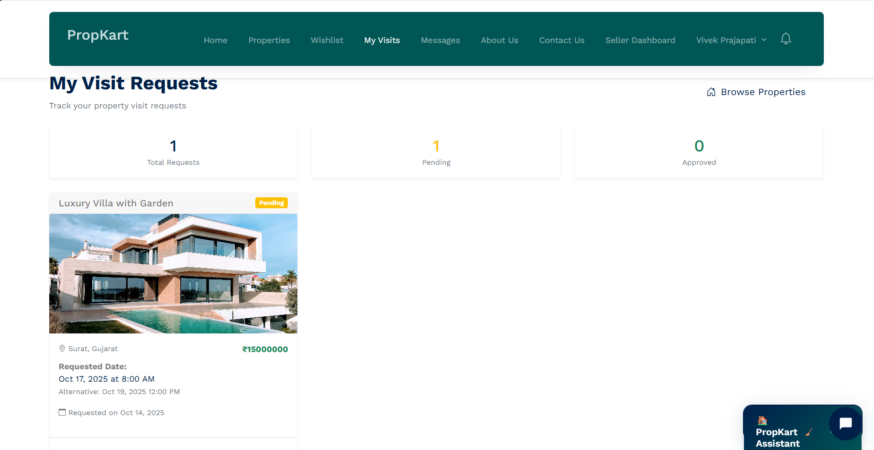

**Screen: The My Visit Requests dashboard for a logged-in user on the PropKart web app.**

**Main content:**

* **Page title: "My Visit Requests".**
* **Subtitle: "Track your property visit requests".**
* **A three-column summary dashboard showing the status of requests:**
  + **1 Total Requests (Black text)**
  + **1 Pending (Yellow text)**
  + **0 Approved (Green text)**
* **A list view of the requested properties, starting with the property card for "Luxury Villa with Garden".**
  + **The card features a property image, the property title, location, and price.**
  + **A "Pending" status tag is visible on the card.**
  + **Detailed request information includes the Requested Date (Oct 17, 2025 at 8:00 AM), an Alternative date/time, and the date the request was submitted (Requested on Oct 14, 2025).**

**Actions:**

* **"Browse Properties" link in the top-right of the main content area for navigation.**
* **Implicit actions would include managing (e.g., viewing details, canceling) the listed visit request, although no buttons are visible on the card itself.**

**My Messages Page**

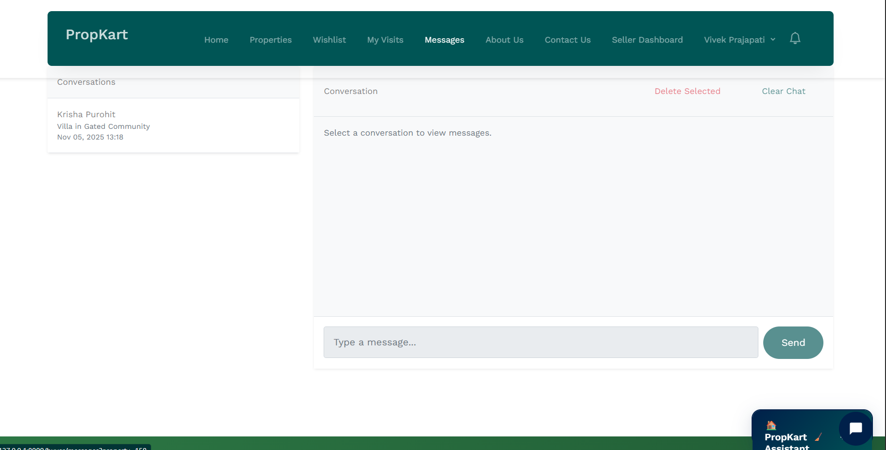

**Screen: The Messages/In-App Chat inbox for the logged-in user on the PropKart web app.**

Main content:

* The page is split into a **Conversation List (Left Panel)** and a **Message Viewer/Composer (Right Panel)**.
* The **Conversation List** is titled **"Conversations"** and shows one entry:
  + Contact Name: **Krisha Purohit**.
  + Subject/Context: **Villa in Gated Community**.
  + Last Message Timestamp: **Nov 05, 2025 13:18**.
* The **Message Viewer** shows the heading **"Conversation"**.
* A prompt indicates: **"Select a conversation to view messages."**
* The bottom of the viewer contains the **message input field** labeled **"Type a message..."** and a **"Send"** button.

Actions:

* **"Delete Selected"** link to remove messages/conversations.
* **"Clear Chat"** link to empty the current conversation view.
* The **"Send"** button is used to submit a message after typing.
* Clicking an entry in the Conversation List (e.g., Krisha Purohit) would load that chat into the viewer.

**Saller Dashboard Page**

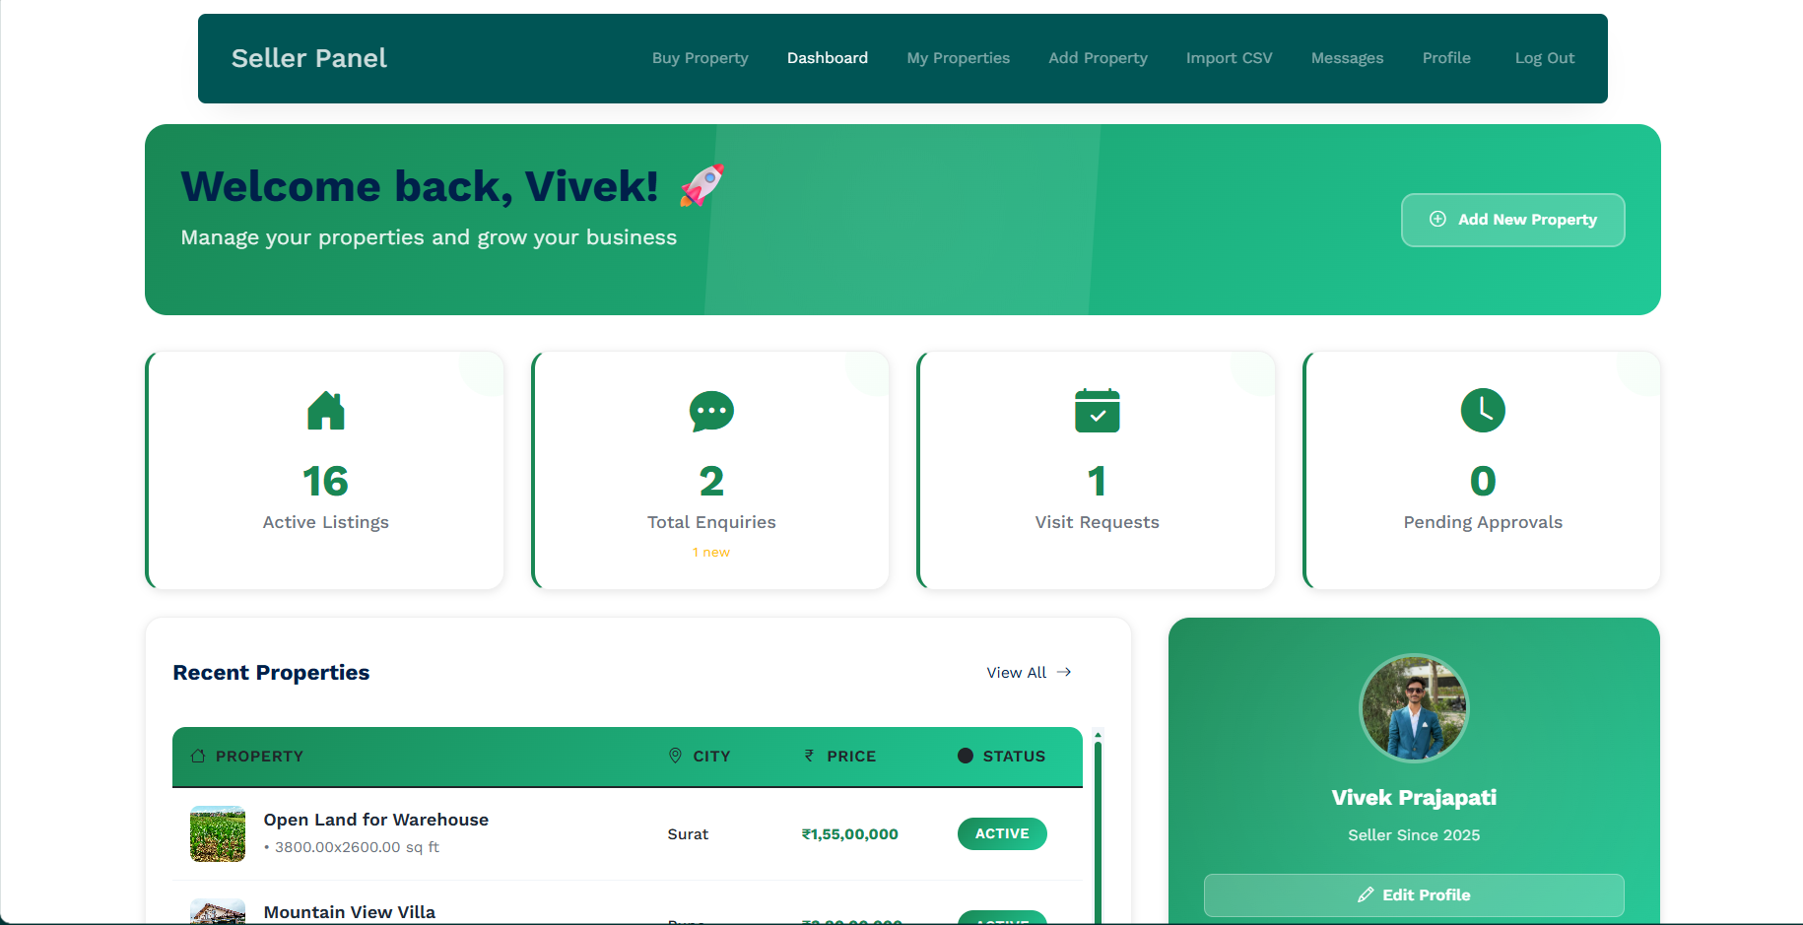

**Screen: The Seller Dashboard/Panel overview page for a logged-in user .**

Main content:

* A prominent green **Welcome Banner** reading **"Welcome back, Vivek!"** with a subtext: "Manage your properties and grow your business."
* A row of **four key performance indicator (KPI) cards** providing a summary of seller activity:
  + **16 Active Listings**
  + **2 Total Enquiries** (with "1 new" highlighted)
  + **1 Visit Requests**
  + **0 Pending Approvals**
* A section titled **"Recent Properties"** listing properties in a table format.
  + The table headers include **PROPERTY**, **CITY**, **PRICE**, and **STATUS**.
  + The first visible entry is for "Open Land for Warehouse" located in **Surat** with a price of **₹1,55,00,000** and a status of **ACTIVE**.
* A **Seller Profile Card** on the right side, showing the user's picture, name , and status (**Seller Since 2025**).

Actions:

* **"Add New Property"** button in the Welcome Banner.
* **"View All"** link next to the "Recent Properties" heading.
* **"Edit Profile"** button on the Seller Profile Card.
* The header contains navigation links for seller functions: **Buy Property, Dashboard (active), My Properties, Add Property, Import CSV, Messages, Profile, Log Out**.

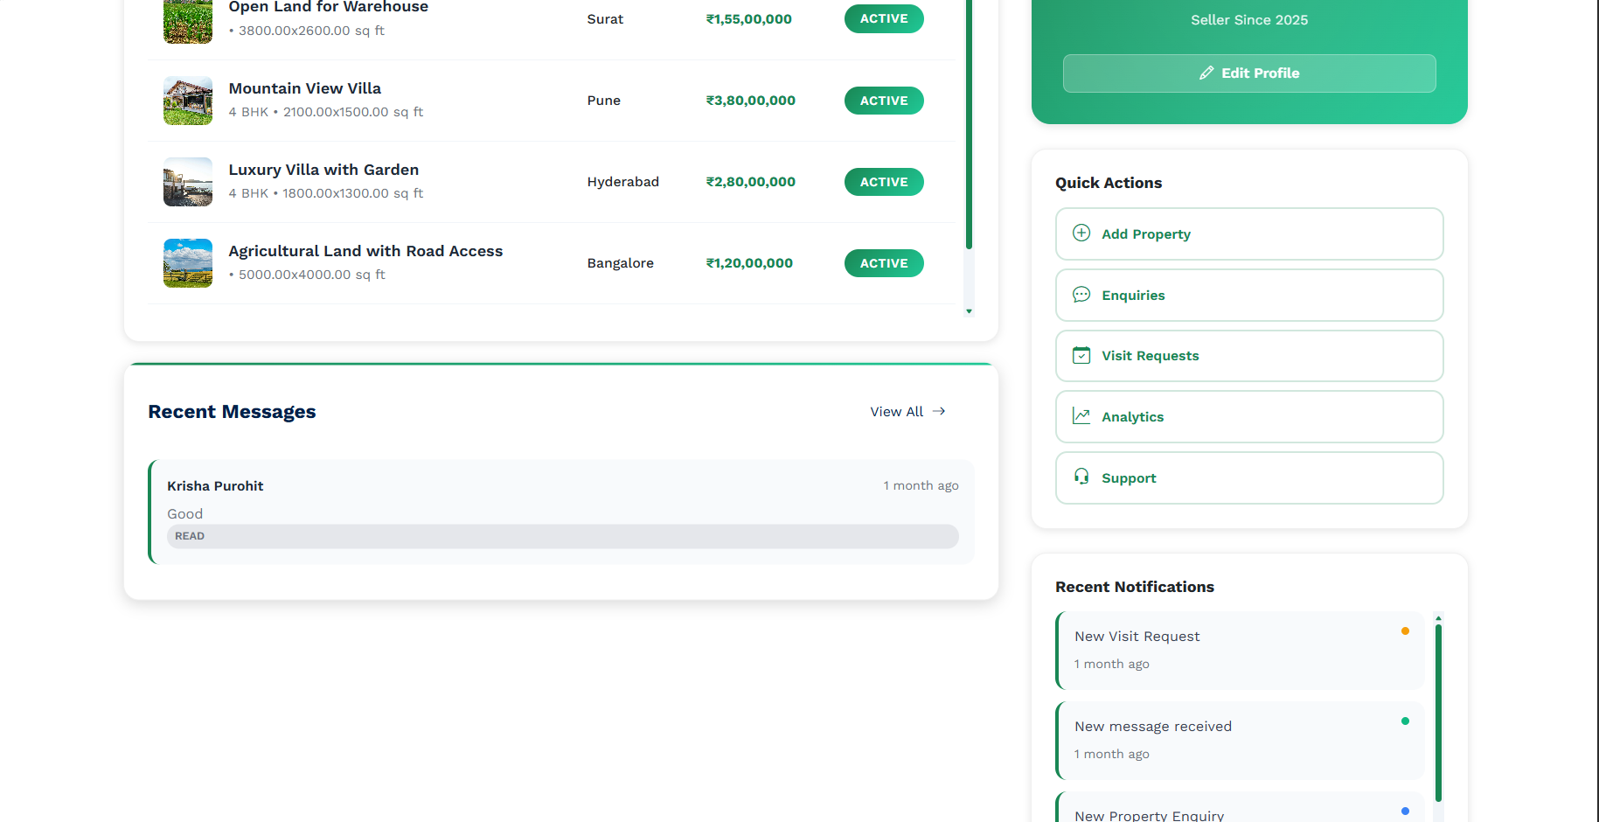

**Screen: Lower section of the Seller Dashboard/Panel overview page.**

Main content:

* The continuation of the **Recent Properties** table from the previous screen, listing three more active properties:
  + **Mountain View Villa** (in Pune)
  + **Luxury Villa with Garden** (in Hyderabad)
  + **Agricultural Land with Road Access** (in Bangalore)
* A section titled **"Recent Messages"** showing a snippet of the latest received message. The entry is from **Krisha Purohit** with the content "Good" and a **"READ"** status, timestamped "1 month ago".
* A **Seller Profile Card** (partial view) on the right side.
* A section titled **"Quick Actions"** listing common tasks with icons:
  + **Add Property**
  + **Enquiries**
  + **Visit Requests**
  + **Analytics**
  + **Support**
* A section titled **"Recent Notifications"** showing a list of recent activities, including:
  + **New Visit Request** ("1 month ago")
  + **New message received** ("1 month ago")
  + **New Property Enquiry** (partially visible)

Actions:

* **"View All"** link next to the "Recent Messages" heading.
* **"Edit Profile"** button on the Seller Profile Card.
* Clicking on any item in the **"Quick Actions"** list or **"Recent Notifications"** list to navigate to the corresponding section.

**Add Property Section**

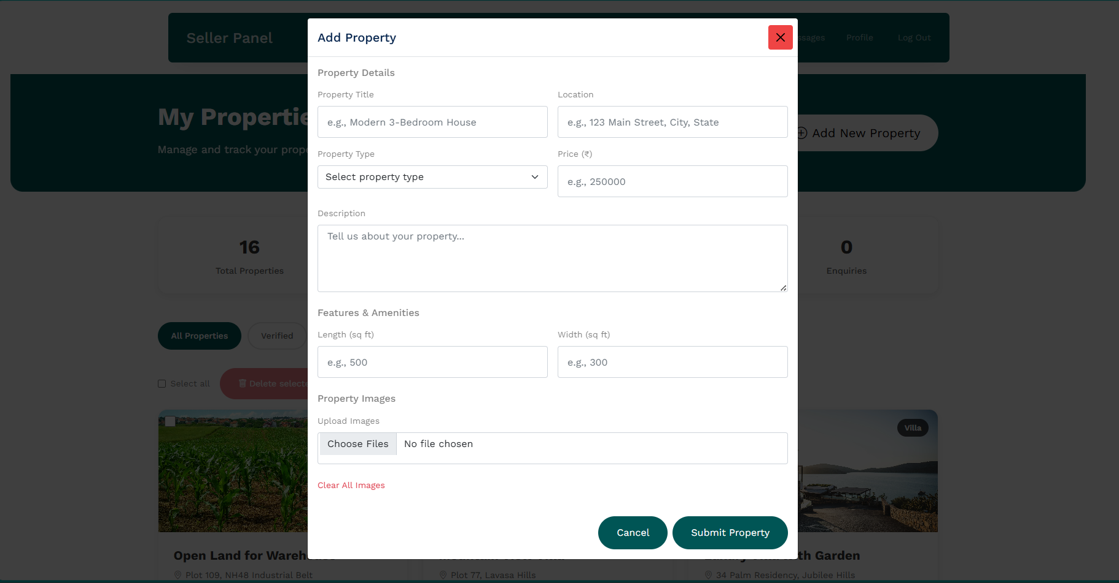

**Screen: A modal overlay for "Add Property" on the Seller Panel's "My Properties" page.**

Main content:

* A **modal form** titled **"Add Property"** is displayed centrally over the existing "My Properties" page content.
* The form is divided into several sections for entering property data:
  + **Property Details**: Includes fields for **Property Title**, **Location**, a dropdown for **Property Type**, a field for **Price (₹)**, and a large text area for **Description**.
  + **Features & Amenities**: Includes input fields for **Length (sq ft)** and **Width (sq ft)**.
  + **Property Images**: Includes a **"Choose Files"** button for image upload and a **"clear All Images"** link.
* Placeholder examples are provided in most input fields (e.g., "e.g., Modern 3-Bedroom House", "e.g., 25000").

Actions:

* **"Submit Property"** button to finalize and submit the new property listing.
* **"Cancel"** button to close the modal form without submitting.
* A close (**X**) icon in the top-right corner of the modal to dismiss the form.

**My Properties Page**

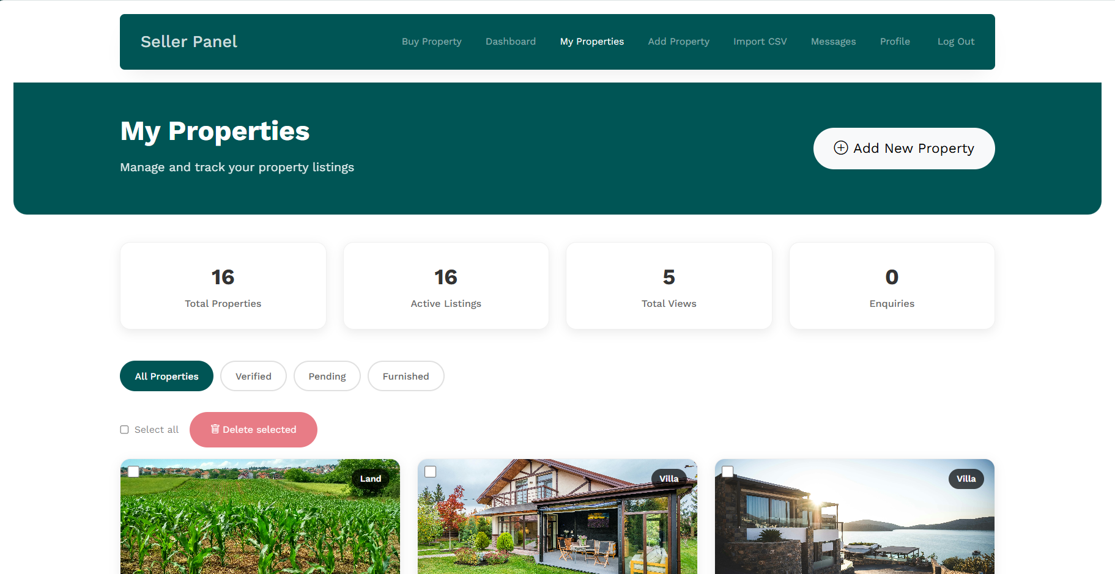

**Screen: The My Properties page within the Seller Panel, showing property management and filtering options.**

**Main content:**

* **A prominent green Header Banner reading "My Properties" with a subtext: "Manage and track your property listings."**
* **A row of four key performance indicator (KPI) cards summarizing the seller's properties:**
  + **16 Total Properties**
  + **16 Active Listings**
  + **5 Total Views**
  + **0 Enquiries**
* **A horizontal row of filter tabs/buttons for property status: All Properties (active), Verified, Pending, Furnished.**
* **A management section with a "Select all" checkbox and a highlighted "Delete selected" button.**
* **The start of the property listings grid is visible, featuring property cards that include a thumbnail image, property type label (Land, Villa), and a selection checkbox.**

**Actions:**

* **"Add New Property" button in the Header Banner.**
* **Clicking the filter tabs (Verified, Pending, Furnished) to change the view of the properties.**
* **"Select all" checkbox for bulk selection.**
* **"Delete selected" button for bulk removal of properties.**
* **Implicit actions would include clicking a property card to view/edit its details.**

**Bulk Insertion Properties Page**

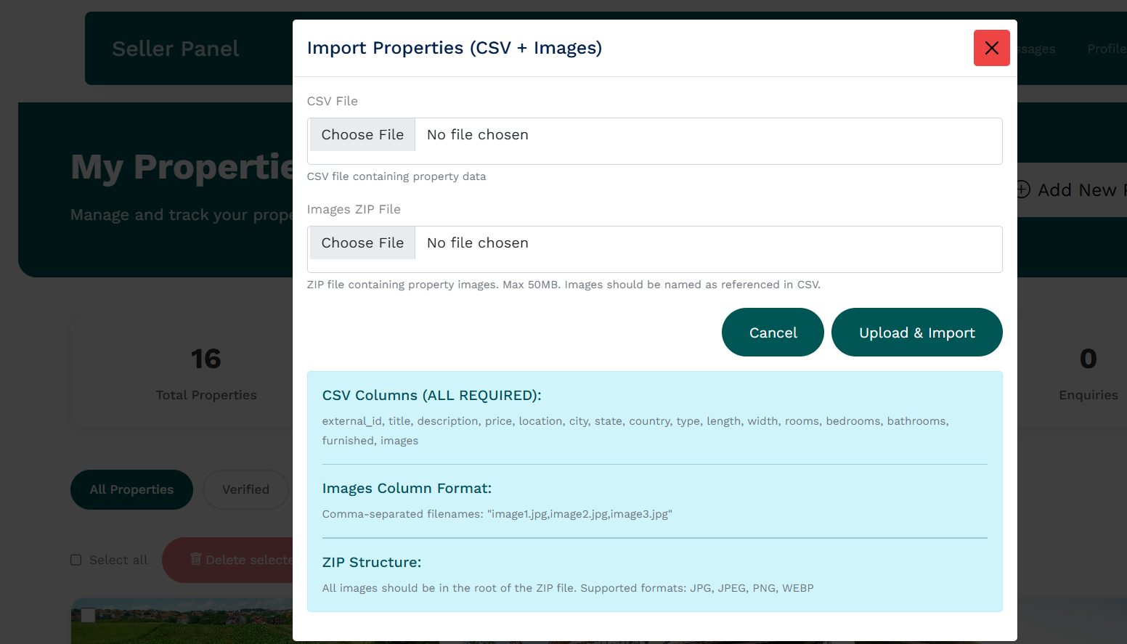

**Screen: A modal overlay for "Import Properties (CSV + Images)" on the Seller Panel.**

**Main content:**

* **A modal form titled "Import Properties (CSV + Images)" for bulk property listing submission.**
* **The form requires two files to be uploaded:**
  + **CSV File: Contains property data. Has a "Choose File" button.**
  + **Images ZIP File: Contains the property images (Max 50MB). Has a "Choose File" button and a note on naming convention.**
* **A prominent informational box at the bottom provides strict format requirements:**
  + **CSV Columns (ALL REQUIRED): Lists 13 required column headers (e.g., external_id, title, description, price, location, city, etc.).**
  + **Images Column Format: Specifies a comma-separated filename structure (e.g., "image1.jpg,image2.jpg,image3.jpg").**
  + **ZIP Structure: States that all images must be in the root of the ZIP file and lists supported formats (JPG, JPEG, PNG, WEBP).**

**Actions:**

* **"Upload & Import" button to execute the bulk import process.**
* **"Cancel" button to close the modal form without importing.**
* **A close (X) icon in the top-right corner of the modal to dismiss the form.**

**Profile Page**

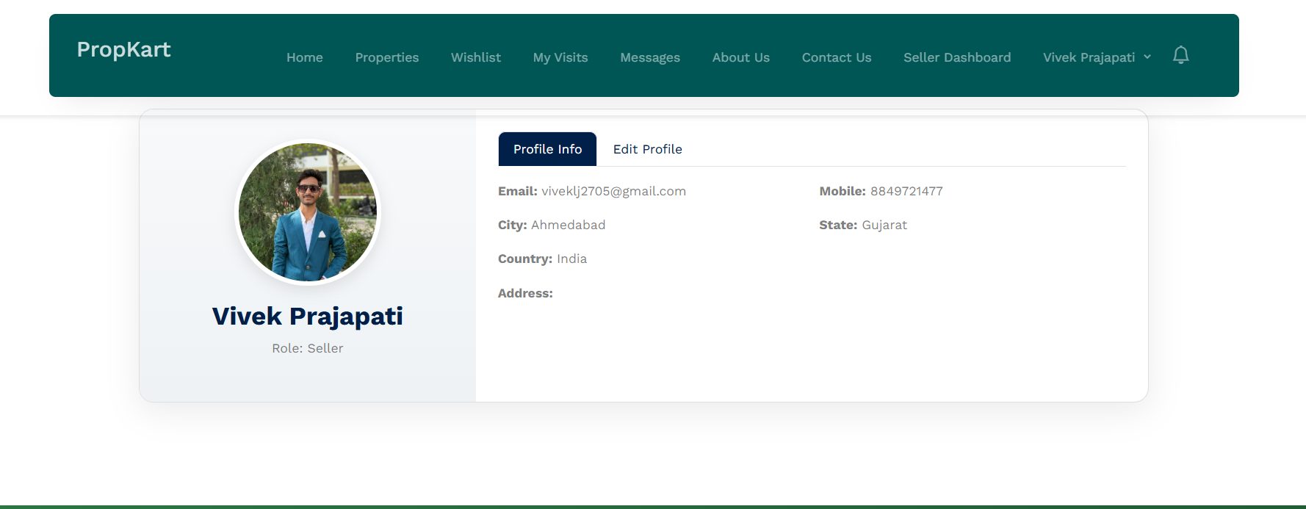

**Screen: A modal overlay for "Import Properties (CSV + Images)" on the Seller Panel.**

**Main content:**

* **A modal form titled "Import Properties (CSV + Images)" for bulk property listing submission.**
* **The form requires two files to be uploaded:**
  + **CSV File: Contains property data. Has a "Choose File" button.**
  + **Images ZIP File: Contains the property images (Max 50MB). Has a "Choose File" button and a note on naming convention.**
* **A prominent informational box at the bottom provides strict format requirements:**
  + **CSV Columns (ALL REQUIRED): Lists 13 required column headers (e.g., external_id, title, description, price, location, city, etc.).**
  + **Images Column Format: Specifies a comma-separated filename structure (e.g., "image1.jpg,image2.jpg,image3.jpg").**
  + **ZIP Structure: States that all images must be in the root of the ZIP file and lists supported formats (JPG, JPEG, PNG, WEBP).**

**Actions:**

* **"Upload & Import" button to execute the bulk import process.**
* **"Cancel" button to close the modal form without importing.**
* **A close (X) icon in the top-right corner of the modal to dismiss the form.**

**Edit Profile Page**

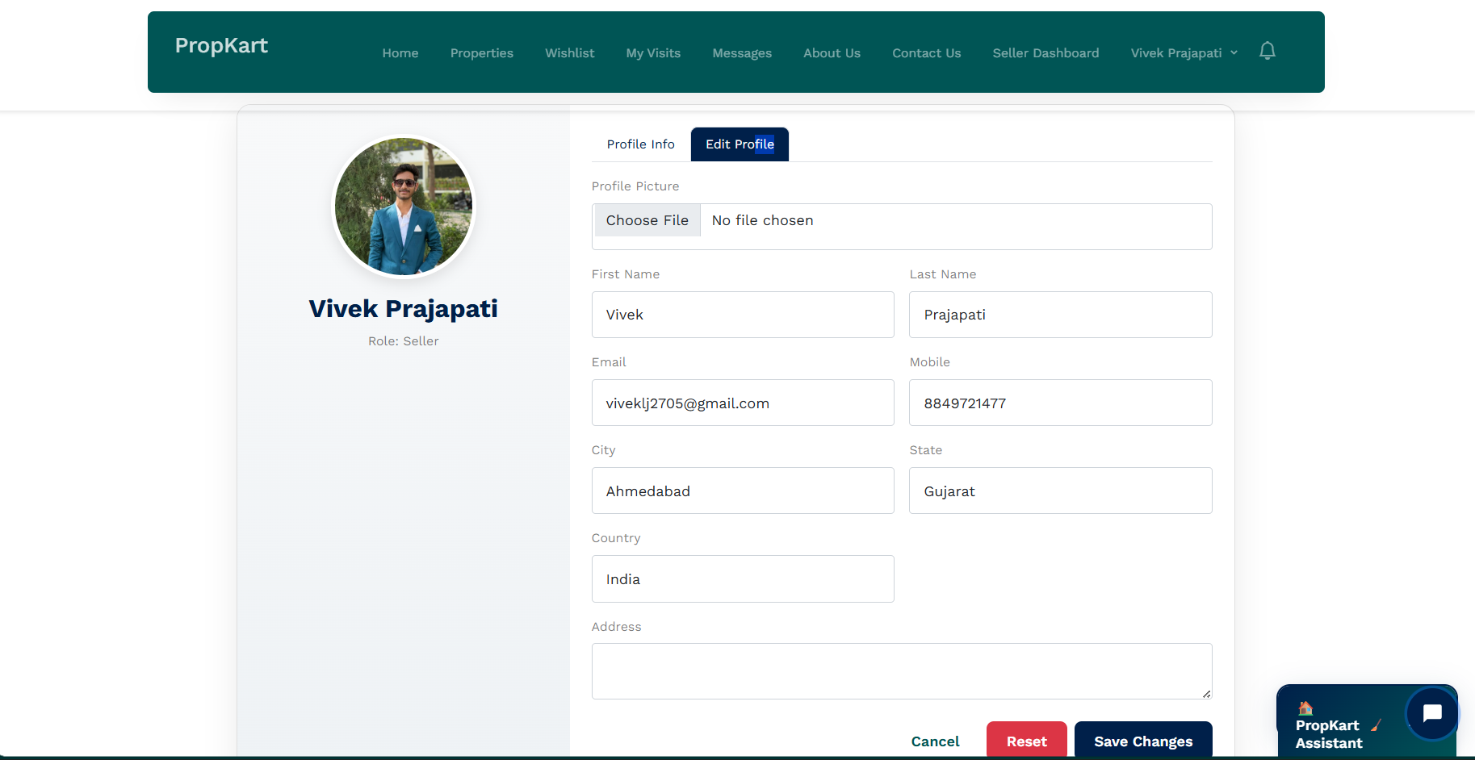

**Screen: The User Profile page displaying the "Edit Profile" interface for the logged-in user .**

**Main content:**

* **The user's profile editing form is displayed within a centered card.**
* **Left Panel: Shows the user's current profile picture, full name , and Role: Seller.**
* **Right Panel: Displays the editable form fields under the active "Edit Profile" tab (next to the inactive "Profile Info" tab).**
* **The form fields include:**
  + **Profile Picture: With a "Choose File" button.**
  + **First Name and Last Name (pre-filled with Vivek and Prajapati).**
  + **Email and Mobile (pre-filled with vivek.lj2705@gmail.com and 8849721477).**
  + **City and State (pre-filled with Ahmedabad and Gujarat).**
  + **Country (pre-filled with India).**
  + **Address (a text area for input).**

**Actions:**

* **"Save Changes" button (blue) to update the profile information.**
* **"Reset" button (red) to revert any changes made in the form.**
* **"Cancel" link to exit the edit mode.**
* **"Profile Info" tab to switch back to the read-only view.**

5. **Agile Documentation**

**5.1 Agile Project Charter**

**General Project Information**

|  |  |
| --- | --- |
| Field | Details |
| Project Name | PropKart Real Estate Platform |
| Project Champion | Prof. Urvika Soni |
| Project Sponsor | L J Institute of Computer Applications |
| Project Manager | Krisha Purohit, Vivek Prajapati |
| Stakeholders | L J Institute of Computer Applications |
| Expected Start Date | 07th July,2025 |
| Expected Completion Date | 15th Oct, 2025 |

**Project Details**

**Mission:** To provide buyers and sellers with an efficient, secure, and user-friendly platform for property discovery, listing management, and streamlined communication through enquiries, visits, and messaging.

**Vision:** To become the preferred real estate marketplace that eliminates fragmentation, reduces manual processes, and builds trust through verified listings and structured workflows.

**Scope**

* **In Scope:**
* User authentication with OTP-based registration and password reset
* Buyer and seller role management with verification
* Property listing management (CRUD, bulk operations, import)
* Property discovery and detailed viewing
* Enquiry and visit request workflows
* Buyer-seller messaging system
* Wishlist functionality
* Notification system
* Seller dashboard with KPIs
* Admin panel for platform management
* AI chat assistant APIs
* **Out of Scope:**
* Payment processing and transactions
* Advanced search and filtering
* Property video uploads
* Mobile application
* Third-party integrations (maps, payment gateways)
* Advanced analytics and reporting

**Success Criteria**

* Successful user registration and authentication flows
* Efficient property listing and discovery
* Streamlined enquiry and visit management
* Reliable messaging between buyers and sellers
* Responsive and intuitive user interface
* Secure data handling and user privacy protection

**Constraints**

* Timeline: Must be completed within the specified project duration
* Budget: Development within allocated resources
* Technology: Django-based web application
* Security: OTP-based authentication and role-based access control
* Performance: Optimized database queries and responsive UI

**Assumptions**

* Users have access to email for OTP verification
* Stable internet connectivity for platform access
* Modern web browsers for optimal user experience
* Sufficient server resources for media storage and processing

**5.2 Agile roadmap/schedule**

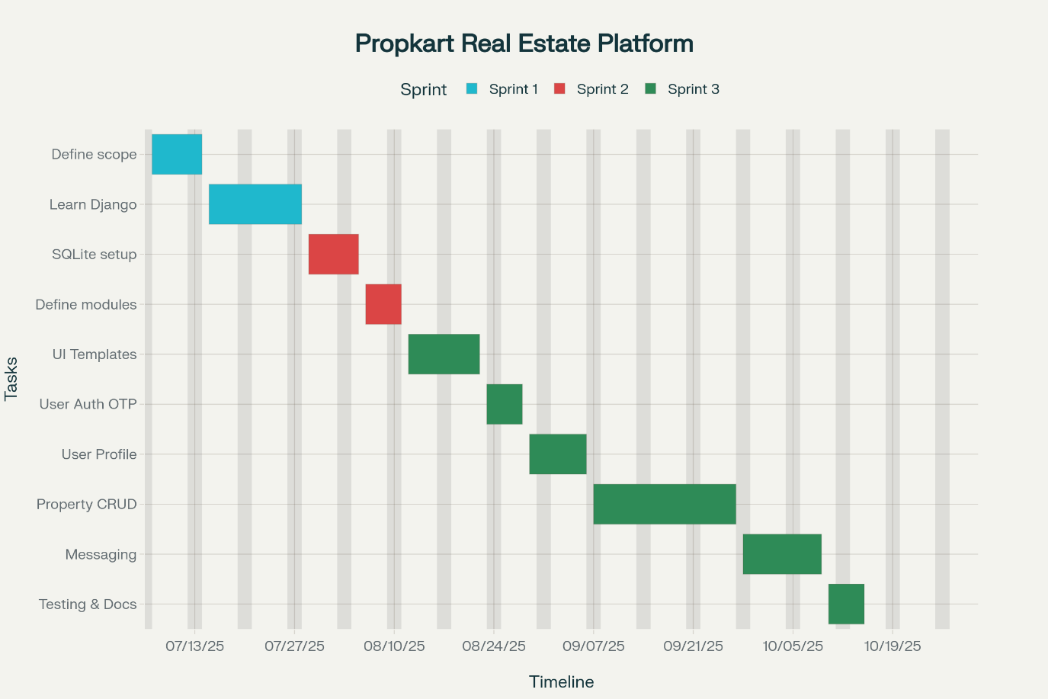

**5.3 Agile Project Plan**

|  |  |  |  |  |
| --- | --- | --- | --- | --- |
| Task Name | Duration | Start | Finish | Status |
| Sprint#1: Requirement Gathering | 22d | 07-07-2025 | 28-07-2025 | Complete |
| Define objective, scope | 8d | 07-07-2025 | 14-07-2025 | Complete |
| Learning Django technology | 14d | 15-07-2025 | 28-07-2025 | Complete |
| Sprint#2: Project Structure | 14d | 29-07-2025 | 11-08-2025 | Complete |
| Database Management (SQLite) | 8d | 29-07-2025 | 05-08-2025 | Complete |
| Define Modules & Models | 6d | 06-08-2025 | 11-08-2025 | Complete |
| Sprint#3: Core Development | 64d | 12-08-2025 | 15-10-2025 | Complete |
| UI Designing (Templates) | 11d | 12-08-2025 | 22-08-2025 | Complete |
| User Authentication (OTP) | 6d | 23-08-2025 | 28-08-2025 | Complete |
| User Profile Management | 8d | 29-08-2025 | 06-09-2025 | Complete |
| Property CRUD Operations | 21d | 07-09-2025 | 27-09-2025 | Complete |
| Messaging & Enquiries | 12d | 28-09-2025 | 09-10-2025 | Complete |
| Testing & Documentation | 6d | 10-10-2025 | 15-10-2025 | Complete |

**Project Summary:**

* **Total Duration:** 100 days (15 weeks)
* **Start Date:** July 7, 2025
* **End Date:** October 15, 2025
* **Sprints:** 3 major sprints
* **Status:** All tasks completed successfully

**Key Deliverables:**

* Requirements documentation and technology setup
* Database schema and model definitions
* Complete web application with authentication, property management, messaging, and admin features

**5.4 Agile User Stories**

|  |  |  |  |
| --- | --- | --- | --- |
| USER STORY | AS USER | WANT TO PERFORM | TO ACHIEVE |
| 1 | Admin | User Management, Property Management, Seller Verification, Platform Oversight | To manage users, verify sellers, moderate listings, and ensure platform quality |
| 2 | Seller | Login/Register, Create/Manage Properties, Handle Enquiries/Visits, View Analytics | To list properties, manage buyer interactions, and track performance |
| 3 | Buyer | Login/Register, Browse/Save Properties, Submit Enquiries/Visits, Message Sellers | To discover properties, express interest, and communicate with sellers |
| 4 | Visitor | Browse Properties, View Details, Submit Basic Enquiries/Visits | To explore properties and initiate contact without registration |
| 5 | System | Send OTP Emails, Track Views, Generate Notifications, Maintain Security | To ensure reliable communication, engagement tracking, and platform security |

**5.5 Agile Release Plan**

|  |  |  |  |  |  |
| --- | --- | --- | --- | --- | --- |
| Task Name | Duration | Start | Finish | Status | Release |
| Sprint#1: Requirement Gathering | 22d | 07-07-2025 | 28-07-2025 | Complete | 27-07-2025 |
| Define objective, scope | 8d | 07-07-2025 | 14-07-2025 | Complete | 14-07-2025 |
| Learning Django technology | 14d | 15-07-2025 | 28-07-2025 | Complete | 28-07-2025 |
| Sprint#2: Project Structure | 14d | 29-07-2025 | 11-08-2025 | Complete | 10-08-2025 |
| Database Management (SQLite) | 8d | 29-07-2025 | 05-08-2025 | Complete | 05-08-2025 |
| Define Modules & Models | 6d | 06-08-2025 | 11-08-2025 | Complete | 11-08-2025 |
| Sprint#3: Core Development | 64d | 12-08-2025 | 15-10-2025 | Complete | 15-10-2025 |
| UI Designing (Templates) | 11d | 12-08-2025 | 22-08-2025 | Complete | 22-08-2025 |
| User Authentication (OTP) | 6d | 23-08-2025 | 28-08-2025 | Complete | 28-08-2025 |
| User Profile Management | 8d | 29-08-2025 | 06-09-2025 | Complete | 06-09-2025 |
| Property CRUD Operations | 21d | 07-09-2025 | 27-09-2025 | Complete | 27-09-2025 |
| Messaging & Enquiries | 12d | 28-09-2025 | 09-10-2025 | Complete | 09-10-2025 |
| Testing & Documentation | 6d | 10-10-2025 | 15-10-2025 | Complete | 15-10-2025 |

**5.6 Agile Sprint Backlog**

|  |  |  |  |  |  |
| --- | --- | --- | --- | --- | --- |
| Task Name | Story | Sprint Ready | Priority | Status | Story Point |
| Sprint#1: Requirement Gathering | Yes | Yes | High | Complete | 10 |
| Define objective, scope | Yes | Yes | High | Complete | 5 |
| Learning Django technology | Yes | Yes | High | Complete | 5 |
| Sprint#2: Project Structure | Yes | Yes | High | Complete | 20 |
| Database Management (SQLite) | Yes | Yes | High | Complete | 10 |
| Define Modules & Models | Yes | Yes | High | Complete | 10 |
| Sprint#3: Core Development | Yes | Yes | High | Complete | 81 |
| UI Designing (Templates) | Yes | Yes | Medium | Complete | 10 |
| User Authentication (OTP) | Yes | Yes | High | Complete | 17 |
| User Profile Management | Yes | Yes | Medium | Complete | 10 |
| Property CRUD Operations | Yes | Yes | High | Complete | 17 |
| Messaging & Enquiries | Yes | Yes | High | Complete | 17 |
| Testing & Documentation | Yes | Yes | Medium | Complete | 10 |

**5.7 Agile Test Plan**

|  |  |  |  |  |  |  |
| --- | --- | --- | --- | --- | --- | --- |
| Sprint | Modules / Features | Test Scenarios | Test Type | Expected Result | Actual Result | Status |
| Sprint 1 | **User Authentication & Profile Management** | **- Valid user registration- Invalid registration (duplicate email, weak password)- Login/logout flow- Password reset via email- Profile update & photo upload- Account deletion** | **Unit / Integration** | **All authentication and profile operations function correctly with validation and persistence** | **Works as expected** | **Yes Pass** |
| Sprint 2 | **Property Management** | **- Create property listing- Edit/delete listings- Upload images- Filter, sort, and search listings- Pagination & listing visibility** | **Functional / Integration** | **Properties can be created, updated, and searched accurately** | **Works as expected** | **Yes Pass** |
| Sprint 3 | **Enquiry & Visit Request System** | **- Submit enquiry for a property- Seller responds to enquiry- Schedule visit with date/time- Modify/cancel visit- Notification upon response** | **Functional / Workflow** | **Enquiries and visit requests work end-to-end with notification** | **Works as expected** | **Yes Pass** |
| Sprint 4 | **Chat & Notifications** | **- Start chat between buyer & seller- Real-time message delivery- View chat history- File/image sharing- New message alerts & notification badges** | **End-to-End / System** | **Real-time chat works with notifications and persistence** | **Works as expected** | **Yes Pass** |
| Sprint 5 | **Security & Performance** | **- Session timeout- CSRF validation- SQL injection check- Load & stress testing- Browser compatibility test** | **Security / Performance** | **System remains secure and performs efficiently under load** | **Works as expected** | **Yes Pass** |

6. Testing

6.1: Testing Methods

|  |  |  |
| --- | --- | --- |
| Testing Type | Category | Scenarios Covered |
| Unit Testing | User Authentication Tests | - Test user registration with valid/invalid data  - Test OTP verification process  - Test login functionality with correct/incorrect credentials  - Test password reset functionality |
| Unit Testing | Property Management Tests | - Test property creation with required fields  - Test property image upload and deletion  - Test property search and filtering  - Test property visibility toggle (is_hidden field) |
| Unit Testing | Wishlist Tests | - Test adding/removing properties to wishlist  - Test wishlist item uniqueness |
| Integration Testing | User-Property Interaction | - Test property listing workflow (create → upload images → publish)  - Test property search and filtering with multiple criteria  - Test user role transitions (buyer to seller) |
| Integration Testing | Communication System | - Test message sending between buyers and sellers  - Test notification system for property updates  - Test chat session management |
| System Testing | End-to-End Workflows | - Complete property buying journey  - Complete property selling journey  - Visit scheduling and management |
| System Testing | Performance Testing | - Load testing for property search  - Image upload and retrieval performance  - Chat system response time |

6.2 Test Cases

**LOGIN**

|  |  |  |  |
| --- | --- | --- | --- |
| Project Name | PropKart Real Estate Platform | Device | Intel Core i5 12th Gen |
| Test Case ID | **TC-AUTH-001** | **Test Title** | **User Login** |
| Module Name | **Authentication** | **Tested By** | **Vivek Prajapati** |
| Priority | **High** | **Execution Date** | **20-08-2025** |

|  |  |  |  |  |  |
| --- | --- | --- | --- | --- | --- |
| Test | Test Step | Action | Expected Result | Actual Result | Pass |
| 1 | Navigate to login page | Open login page | Login page should be displayed correctly | Login page displayed correctly | Yes |
| 2 | Login with valid buyer credentials | Enter registered buyer email and correct password | Redirect to Buyer Dashboard | Redirected to Buyer Dashboard | Yes |
| 3 | Login with valid seller credentials | Enter registered seller email and correct password | Redirect to Seller Dashboard | Redirected to Seller Dashboard | Yes |
| 4 | Login with invalid password | Enter valid email and wrong password | Show “Invalid credentials” message | Error message displayed | Yes |
| 5 | Login with unregistered email | Enter unregistered email | Show “User not found” error | Error message displayed | Yes |
| 6 | Login with empty fields | Submit without entering data | Show “Fields required” error | Validation error shown | Yes |
| 7 | Login with SQL-injection input | Enter ' OR '1'='1 in email | Prevent login, show “Invalid credentials” | Login blocked, error shown | Yes |
| 8 | Remember me functionality | Tick “Remember Me” and login | User remains logged in on next session | User remained logged in | Yes |

**REGISTRATION**

|  |  |  |  |
| --- | --- | --- | --- |
| Project Name | PropKart Real Estate Platform | Device | Intel Core i7 11th Gen |
| Test Case Id | 2 | Test Title | User Registration |
| Module Name | Authentication | Tested By | Krisha Purohit |
| Priority | High | Execution Date | 21-08-2025 |

|  |  |  |  |  |  |
| --- | --- | --- | --- | --- | --- |
| Test | Test Step | Action | Expected Result | Actual Result | Pass |
| 1 | Navigate to registration page | Open signup page | Registration page should be visible | Page visible | Yes |
| 2 | Valid registration | Enter all required valid details | Account created and verification email sent | Account created successfully | Yes |
| 3 | Verify OTP | Enter correct OTP from email | Account activated | Account activated | Yes |
| 4 | Registration with existing email | Enter already registered email | Show “Email already exists” | Error shown | Yes |
| 5 | Weak password | Enter password less than 8 chars | Show “Weak password” error | Validation error shown | Yes |
| 6 | Invalid email format | Enter invalid email | Show “Invalid email format” | Validation error shown | Yes |
| 7 | Empty required fields | Leave mandatory fields empty | Show “Field required” | Validation error shown | Yes |
| 8 | Mismatched passwords | Enter different passwords in confirm field | Show “Passwords do not match” | Error shown | Yes |

**PASSWORD RESET**

|  |  |  |  |
| --- | --- | --- | --- |
| Project Name | PropKart Real Estate Platform | Device | Intel Core i5 12th Gen |
| Test Case Id | 3 | Test Title | Password Reset |
| Module Name | Authentication | Tested By | Vivek Prajapati |
| Priority | High | Execution Date | 22-08-2025 |

|  |  |  |  |  |  |
| --- | --- | --- | --- | --- | --- |
| Test | Test Step | Action | Expected Result | Actual Result | Pass |
| 1 | **Navigate to forgot password** | **Open forgot password page** | **Forgot password page should load** | **Page loaded successfully** | **Yes** |
| 2 | **Enter valid email** | **Submit registered email** | **OTP sent to email** | **OTP received** | **Yes** |
| 3 | **Enter unregistered email** | **Submit unregistered email** | **Show “Email not found”** | **Error shown** | **Yes** |
| 4 | **Enter incorrect OTP** | **Enter wrong OTP** | **Show “Invalid OTP”** | **Error shown** | **Yes** |
| 5 | **Enter correct OTP** | **Enter valid OTP** | **Allow password reset** | **Reset form opened** | **Yes** |
| 6 | **Set new password** | **Enter and confirm new password** | **Password updated successfully** | **Password updated** | **Yes** |
| 7 | **Login with new password** | **Login using new password** | **Login successful** | **Login successful** | **Yes** |

**PROPERTY LISTING**

|  |  |  |  |
| --- | --- | --- | --- |
| Project Name | PropKart Real Estate Platform | Device | Intel Core i7 11th Gen |
| Test Case Id | 4 | Test Title | Create Property |
| Module Name | Property Management | Tested By | Krisha Purohit |
| Priority | High | Execution Date | 15-09-2025 |

|  |  |  |  |  |  |
| --- | --- | --- | --- | --- | --- |
| Test | Test Step | Action | Expected Result | Actual Result | Pass |
| 1 | **Navigate to add property** | **Open add property form** | **Form should display correctly** | **Form displayed** | **Yes** |
| 2 | **Add valid details** | **Fill all required property info** | **Property created successfully** | **Property created** | **Yes** |
| 3 | **Upload images** | **Upload valid JPG/PNG files** | **Images uploaded successfully** | **Uploaded** | **Yes** |
| 4 | **Upload large file** | **Upload >5MB image** | **Show “File size exceeded”** | **Error shown** | **Yes** |
| 5 | **Submit empty form** | **Leave all fields blank** | **Validation error shown** | **Error displayed** | **Yes** |
| 6 | **Edit property** | **Modify details and save** | **Property updated** | **Updated successfully** | **Yes** |
| 7 | **Delete property** | **Click delete option** | **Property removed** | **Property deleted** | **Yes** |

**PROPERTY DISCOVERY**

|  |  |  |  |
| --- | --- | --- | --- |
| Project Name | PropKart Real Estate Platform | Device | Intel Core i5 12th Gen |
| Test Case Id | 5 | Test Title | Browse Properties |
| Module Name | Property Discovery | Tested By | Vivek Prajapati |
| Priority | Medium | Execution Date | 20-09-2025 |

|  |  |  |  |  |  |
| --- | --- | --- | --- | --- | --- |
| Test | Test Step | Action | Expected Result | Actual Result | Pass |
| 1 | **Open property catalog** | **Navigate to listings** | **All active properties displayed** | **Displayed successfully** | **Yes** |
| 2 | **Basic search** | **Search by title or city** | **Matching results shown** | **Results accurate** | **Yes** |
| 3 | **Advanced filters** | **Apply price, location, type filters** | **Filtered results displayed** | **Results filtered correctly** | **Yes** |
| 4 | **No match** | **Enter random string** | **Show “No results found”** | **Message displayed** | **Yes** |
| 5 | **Sort properties** | **Sort by price, newest** | **Results reordered** | **Sorted successfully** | **Yes** |
| 6 | **Pagination** | **Navigate to next page** | **Next results load properly** | **Pagination works** | **Yes** |

**MESSAGING SYSTEM**

|  |  |  |  |
| --- | --- | --- | --- |
| Project Name | PropKart Real Estate Platform | Device | Intel Core i7 11th Gen |
| Test Case Id | 6 | Test Title | Send Message |
| Module Name | Communication | Tested By | Krisha Purohit |
| Priority | High | Execution Date | 05-10-2025 |

|  |  |  |  |  |  |
| --- | --- | --- | --- | --- | --- |
| Test | Test Step | Action | Expected Result | Actual Result | Pass |
| 1 | **Open messaging page** | **Click “Messages”** | **Page should open** | **Opened successfully** | **Yes** |
| 2 | **Send message** | **Type and send text** | **Message delivered** | **Delivered successfully** | **Yes** |
| 3 | **Receive message** | **Check inbox** | **Message received** | **Message visible** | **Yes** |
| 4 | **Send empty message** | **Click send with no text** | **Show “Cannot send empty message”** | **Error shown** | **Yes** |
| 5 | **File attachment** | **Send image/pdf** | **File uploaded successfully** | **Uploaded** | **Yes** |
| 6 | **Check chat history** | **Open conversation** | **All past messages shown** | **History displayed** | **Yes** |

**VISIT REQUESTS**

|  |  |  |  |
| --- | --- | --- | --- |
| Project Name | PropKart Real Estate Platform | Device | Intel Core i5 12th Gen |
| Test Case Id | 7 | Test Title | Request Visit |
| Module Name | Visit Management | Tested By | Vivek Prajapati |
| Priority | Medium | Execution Date | 08-10-2025 |

|  |  |  |  |  |  |
| --- | --- | --- | --- | --- | --- |
| Test | Test Step | Action | Expected Result | Actual Result | Pass |
| 1 | **Request visit** | **Fill visit form** | **Request submitted** | **Submitted successfully** | **Yes** |
| 2 | **Approve visit** | **Seller approves** | **Status changes to “Approved”** | **Updated correctly** | **Yes** |
| 3 | **Reject visit** | **Seller rejects** | **Status = “Rejected”** | **Updated** | **Yes** |
| 4 | **Cancel visit** | **Buyer cancels** | **Status = “Cancelled”** | **Updated** | **Yes** |
| 5 | **View visit history** | **View past visits** | **All visits displayed** | **Shown correctly** | **Yes** |

**SELLER DASHBOARD**

|  |  |  |  |
| --- | --- | --- | --- |
| Project Name | PropKart Real Estate Platform | Device | Intel Core i7 11th Gen |
| Test Case Id | 8 | Test Title | Seller Dashboard |
| Module Name | Seller Management | Tested By | Krisha Purohit |
| Priority | High | Execution Date | 10-10-2025 |

|  |  |  |  |  |  |
| --- | --- | --- | --- | --- | --- |
| Test | Test Step | Action | Expected Result | Actual Result | Pass |
| 1 | **Open seller dashboard** | **Navigate to dashboard** | **Dashboard loads** | **Dashboard loaded** | **Yes** |
| 2 | **View property stats** | **Check stats cards** | **Property count displayed** | **Displayed correctly** | **Yes** |
| 3 | **View enquiry stats** | **Check total enquiries** | **Count displayed** | **Displayed correctly** | **Yes** |
| 4 | **View visits stats** | **Check visit section** | **Total visits displayed** | **Displayed** | **Yes** |
| 5 | **View views stats** | **Check property views** | **Count displayed** | **Displayed** | **Yes** |

**ADMIN PANEL**

|  |  |  |  |
| --- | --- | --- | --- |
| Project Name | PropKart Real Estate Platform | Device | Intel Core i5 12th Gen |
| Test Case Id | 9 | Test Title | Admin Functions |
| Module Name | Administration | Tested By | Vivek Prajapati |
| Priority | Medium | Execution Date | 12-10-2025 |

|  |  |  |  |  |  |
| --- | --- | --- | --- | --- | --- |
| Test | Test Step | Action | Expected Result | Actual Result | Pass |
| 1 | **Login as admin** | **Enter admin credentials** | **Admin dashboard loads** | **Loaded successfully** | **Yes** |
| 2 | **Manage users** | **Open user list** | **All users displayed** | **Displayed** | **Yes** |
| 3 | **Manage properties** | **Open property list** | **All properties visible** | **Displayed** | **Yes** |
| 4 | **Approve property** | **Approve pending property** | **Status updated** | **Updated** | **Yes** |
| 5 | **Reject property** | **Reject property** | **Status updated** | **Updated** | **Yes** |
| 6 | **View platform stats** | **Open analytics page** | **Overall stats shown** | **Displayed** | **Yes** |

**7. PROPOSED ENHANCEMENT**

**UI Enhancement**

* Implement responsive design for mobile devices
* Add dark mode theme option
* Enhance property image gallery with zoom functionality
* Integrate interactive maps for property locations
* Add advanced filtering and sorting options
* Implement real-time notifications with push notifications
* Create modern dashboard with data visualization charts

**Direct Interaction between Admin and Users**

* Implement in-app chat system for admin support
* Add ticket-based support system for user issues
* Create admin notification system for user complaints
* Implement live chat widget for immediate assistance
* Add user feedback and rating system
* Create admin dashboard for monitoring user interactions

**More Reports**

* Generate comprehensive analytics reports for sellers
* Create market trend analysis reports
* Implement user engagement metrics
* Add financial reports for property transactions
* Create performance reports for platform optimization
* Generate monthly/yearly summary reports for stakeholders

**8. CONCLUSION**

The PropKart Real Estate Platform developed in Django serves as a comprehensive and interactive marketplace that bridges the communication gap between property buyers, sellers, and platform administrators. By leveraging Django as the server-side framework, the platform ensures robust functionality, seamless data handling, and dynamic content generation.

Key features such as user authentication with OTP verification, property listing and management, buyer-seller messaging, visit scheduling, enquiry system, wishlist functionality, and admin panel contribute to an engaging and efficient user experience. The integration of SQLite database allows for secure and efficient data storage, ensuring data consistency and easy retrieval.

The platform successfully addresses the fragmented nature of traditional real estate discovery by providing a centralized hub for property listings, structured communication workflows, and comprehensive management tools. The role-based access control ensures security while the notification system keeps all stakeholders informed of important updates.

In conclusion, the PropKart Real Estate Platform developed in Django is an efficient and scalable solution that enhances the digital presence of real estate transactions while improving accessibility, communication, and management processes for all stakeholders involved in the property marketplace.

**9. PROJECT LEARNINGS**

**Technical Skills Acquired**

* **Django Framework:** Gained comprehensive understanding of Django's MVC architecture, models, views, templates, and URL routing
* **Database Management:** Learned to design and implement relational database schemas with proper foreign key relationships
* **Authentication Systems:** Implemented secure OTP-based authentication and role-based access control
* **File Handling:** Developed skills in handling file uploads, image processing, and media storage management
* **Email Integration:** Learned to integrate SMTP services for automated email notifications and OTP delivery

**Development Process Insights**

* **Agile Methodology:** Experienced the benefits of iterative development with clear sprint planning and regular deliverables
* **Version Control:** Learned the importance of Git for collaborative development and code management
* **Testing Practices:** Understood the significance of comprehensive testing for ensuring application reliability
* **Documentation:** Realized the value of proper documentation for project maintenance and knowledge transfer

**Problem-Solving Skills**

* **Debugging:** Developed systematic approaches to identify and resolve application bugs
* **Performance Optimization:** Learned to optimize database queries and improve application performance
* **Security Implementation:** Gained knowledge of web security best practices and vulnerability prevention
* **User Experience Design:** Understood the importance of intuitive user interfaces and smooth user workflows

**Team Collaboration**

* **Communication:** Improved coordination between team members for effective project delivery
* **Task Distribution:** Learned to break down complex features into manageable development tasks
* **Code Review:** Understood the importance of peer review for maintaining code quality
* **Project Management:** Gained experience in managing timelines, priorities, and deliverables

**10. BIBLIOGRAPHY**

1. https://getbootstrap.com - Bootstrap CSS Framework Documentation
2. https://docs.djangoproject.com - Django Official Documentation
3. https://www.python.org - Python Programming Language Documentation
4. https://www.sqlite.org - SQLite Database Documentation
5. https://www.w3schools.com - Web Development Tutorials
6. https://stackoverflow.com - Developer Community and Solutions
7. https://github.com - Version Control and Code Repository
8. https://realpython.com - Python and Django Learning Resources
9. https://docs.python.org/3/ - Python Standard Library Documentation
10. https://www.djangoproject.com/start/ - Django Getting Started Guide
11. https://docs.djangoproject.com/en/stable/topics/db/models/ - Django Models Documentation
12. https://docs.djangoproject.com/en/stable/topics/auth/ - Django Authentication Documentation
13. https://docs.djangoproject.com/en/stable/topics/templates/ - Django Templates Documentation
14. https://docs.djangoproject.com/en/stable/topics/testing/ - Django Testing Documentation